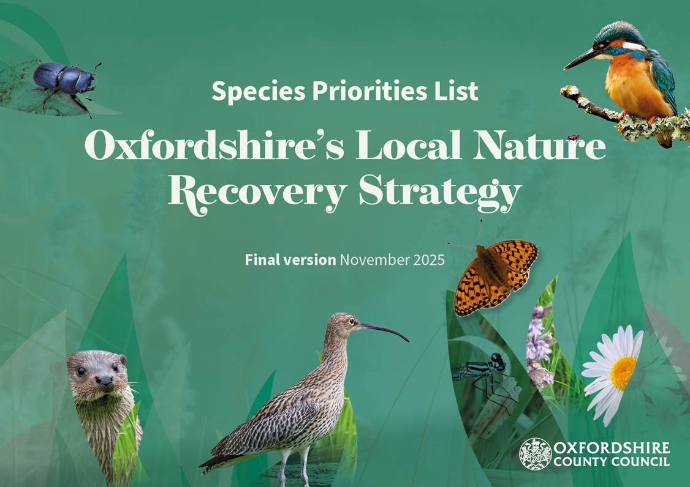
Please report sightings of these species to Thames Valley Environmental Records Centre to inform future work 1

Contents
Introduction 3
What is the Species Priorities List? 3
How was this list made? 4
How will LNRS ‘Species Priorities Lists’ contribute towards the government’s species ambitions? 6
A note on climate change 6
How to navigate this document? 7
Amphibians 9
Birds 10
Butterflies and moths 22
Fish, crustaceans and molluscs 32
Fungi and lichens 37
Insects and spiders 39
Mammals 46
Plants, flowers and trees 55
Reptiles 66
Summary 68
Acknowledgements 69
Images and credits 70
Appendix A 72
Appendix B 73

Introduction
‘Species’ are the types of animals, plants, fungi, and other living things that exist as part of nature. Local Nature Recovery Strategies (LNRS) are designed to help to recover populations of species, especially those who are at risk of extinction from the local area.

Many species are expected to benefit from general habitat improvement and creation actions (e.g. enhancing woodlands and creating ponds). The LNRS already recommends these general habitat actions on the LNRS’s ‘Statement of Biodiversity Priorities’ document and this should benefit a wide range of species. However, some species need more specific actions that aren’t part of general habitat creation or enhancements. To ensure that the LNRS also supports those species with more specific needs, this document identifies those species in Oxfordshire which are believed to need more targeted recovery actions. This list is expected to be reviewed and republished every 3 – 10 years along with all other LNRS documents. The exact timing of the review is decided by the Secretary of State.

What is the Species Priorities List?
The ‘LNRS Species Priorities List’ is one of four parts of the LNRS (there are three written documents and one map tool). The Species Priorities List is a table of species that need very specific actions to support them to survive, recover, or spread further in Oxfordshire. The Government asked for these LNRS Species Priorities Lists to contain a manageable number of deliverable actions to help focus local resources towards halting the loss of biodiversity. LNRSs were advised to include the species that are most likely to benefit from specific, targeted actions as well as species which the local area has a particular national stronghold of.

In brief, the species on this list are all species that require specific actions over and above the general good management and creation of diverse habitats.

Examples of such specific actions that could be suitable for this list include bespoke habitats being created or managed in a particular way for certain species, reintroductions and translocations of species, or taking practical actions to stop the negative impacts of a particular threat or pressure on a species. These actions must be above and beyond the actions we have already listed on the Statement of Biodiversity Priorities.

How was this list made?
This ‘Species Priorities List’ was produced in steps following a methodology created by Natural England and Defra which can be viewed on the LNRS website. First, the LNRS asked Thames Valley Environmental Records Centre (TVERC) to identify which species in Oxfordshire are considered to be ‘threatened’ or ‘near threatened’ with extinction. This list was 879 species long.

We then invited local species experts to review the list and add any species that they thought we had missed, the number of species on this list rose to 883. Next, the list of 883 species were reviewed, one-by-one to work out what action they would need to recover. Some may need bigger woodlands, others may need particular grazing patterns, and some may need more research. Based on the type of action that the species needed, the LNRS assigned them into a certain category (seen in the table below). For a full description of the process, see the LNRS website.

A | B | C | D | E | F | G
Needs more / bigger / better / more connected habitats | Needs targeted habitat management | Needs improvements in environmental quality | Needs bespoke conservation action(s) | Needs better evidence base / on-the-ground action isn’t the  priority | Needs action outside of England | Vagrant species / occasional visitors / invasive species
These species are likely to benefit from the LNRS measures (actions) listed on the Statement of Biodiversity Priorities and do not need to be singled out for  specific LNRS Species actions. | Yes, these species are likely to be suitable for LNRS species priorities | Yes, likely to be suitable for LNRS species priorities | Yes, likely to be suitable for LNRS species priorities.  (Species which have no/poor data about their locations should be assigned to Category E.) | Not suitable for LNRS species priorities list | Not suitable for LNRS species priorities list | Not suitable for LNRS species priorities list

The categories (A – G) in the table were created by Natural England to support LNRSs to separate species out. We categorised each and all of the 883 species into the categories A – G with support from Thames Valley Environmental Centre and local species experts. Experts helped to add and remove species from categories, sense-check the process, inform the LNRS about which species needed which actions, which locations are important for which species, and the types of habitats that these species rely on for survival.

During the process of separating species into categories and working out which actions they needed, there were many species that were expected to benefit from widespread, broad, habitat-level actions (e.g. enhancing grasslands, leaving deadwood in woodlands, creating ponds).

These widespread habitat actions are already recommended in the LNRS’s ‘Statement of Biodiversity Priorities’ which means that the LNRS has already listed the actions which should support the recovery of those species. They haven’t therefore been listed again here. In comparison, there were some species that need a more specific action (e.g. create
electric fencing around nests to prevent predators from getting to them).

Since the actions are quite specific, they would likely be missed out of general habitat creation or management techniques but listing them individually here allows the LNRS to focus effort towards their more specific recovery needs. To halt the loss of biodiversity in Oxfordshire, it is of key importance to support both sets of priorities (the specific species actions on this list, and the habitat-level actions on the ‘Statement of Biodiversity Priorities’).

How will LNRS ‘Species Priorities Lists’ contribute towards the government’s species ambitions?
The government has set legally binding targets to:
- Halt the decline in species abundance by the end of 2030
- Increase species abundance by the end of 2042 so that is greater than in 2022 and at least 10 per cent greater than in 2030
- Reduce the risk of species’ extinction by 2042, when compared to the risk of species’ extinction in 2022

LNRSs were advised by the government’s Department for the Environment, Food, and Rural Affairs (DEFRA) that the “LNRS is a critical new tool for driving the national ambition to increase species abundance and reduce risk of species extinctions… the LNRS system forms a coordinated spatial approach for planning a nationwide network of more, bigger, better, better-connected habitat to support species recovery and resilience. Each strategy contributes to this national picture by planning coherent ecological networks at the local level to help local species populations thrive.”
To support species, LNRSs are advised to follow particular processes to create a written list of local priority species and to propose specific measures (actions) which would help to recover and enhance local populations. In some suitable cases, actions have been mapped onto the LNRSs ‘Local Habitat Map’ to show where those actions could produce the greatest benefits for the species. This may be particularly important where isolated populations of rare species remain.

A note on climate change
At the time of writing, the below actions were expected to be the most suitable ways to support the recovery of these species. However, there are expected changes to climate patterns with warmer, wetter winters and hotter, drier summers predicted, as well as increasing extremes in weather events and storms, although these changing patterns may be unpredictable. The LNRS recommends that the actions listed on the following pages should be adapted based on the latest understanding of changing climates in order to best support the recovery of these species

How to navigate this document?
The target species in this document are organised into broad categories shown in bold below. The categories are then organised in alphabetical order. You can click on any of the headings on the page below to navigate to the relevant species. For species in the groupings below, most will have a picture, their name, and a map which you can see through the link at the end of the document.

Next to their name is a column that tells you:
- the recommended action (potential measure) to support their recovery
- a column that tells you particular locations where focused effort could be beneficial (if known)
- a column with names of other threatened and near threatened species that would also benefit from the action.

You can view a list of these species in alphabetic order in Appendix A at the end of this document.
Key

Settlements and buildings | 
Agricultural land | 
Semi-natural grasslands | 

Freshwater and wetlands
Woodlands and trees

Amphibians
  - Great crested newt.

Birds
  - Bittern (and Marsh harrier), Breeding waders, Curlew, Farmland birds, Montagu’s harrier, Nightingale, Stone curlew, Swifts and House martins, Tawny owl, Turtle dove, Willow tit.

Butterflies and moths
  - Barberry carpet moth, Blackthorn butterflies, Dark green fritillary, Duke of burgundy butterfly, Liquorice piercer moth, Moths of Dyer’s greenweed, Silver spotted skipper, Small blue butterfly, Striped lychnis moth, White admiral, White letter hairstreak, Wood white butterfly.

Fish, crustaceans, and snails
  - Fish, White clawed crayfish, Desmoulin’s whorl snail, Mountain bulin snail.

Fungi and Lichens
  - Fungi and fungi-associated plants found with woodland, Lichens (on veteran trees).

Insects and spiders
  - Beetle of Autumn gentian, Cigarello gall-fly, Clubbed general soldierly, Dung specialists and dung beetles, Ellipteroides alboscutellatus, Lousewort flea beetle, Meadow ant hoverfly, Noble chafer, Snail killing fly, Southern
Damselfly, Spider (Tuberta maerens).

Mammals
  - Bats, Beaver, Hazel dormouse, Hedgehog, Otter, Water vole.

Plants, flowers, and trees
  - Black poplar, Creeping marshwort, Devil’s bit scabious (and Marsh fritillary), Downy
woundwort, Fen violet, Greater water-parsnip, Juniper, Limestone fern, Long-leaved helleborine, Meadow clary, Military orchid, Monkey orchid.

Reptiles
  - Adder, Common lizard.

The next pages contain the Species Priorities List for Oxfordshire.

Amphibians

Species by  Common Name (ordered A – Z) | Potential measure (the action needed to help the relevant species to recover). Potential measures are in bold with additional detail about the species added below. | Particularly important locations  for the action(s) | Which species are intended to benefit  most? | Habitat
Great-Crested Newt  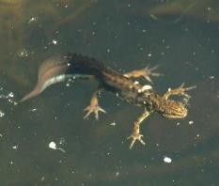  Link to map | Create or maintain fish free ponds, which ideally are within 1km of other ponds that could support Great Crested Newts.  Aim to have diversity within pond structure, depth, shape, and edge vegetation. Include a gently sloping entrance to suitable pond edges. Within suitable range of breeding ponds, ensure the existence of foraging habitats and undisturbed areas of deadwood or stones for hibernation which can include creating hibernacula. New development/infrastructure could include amphibian-friendly landscaping e.g. dropped kerbs, wildlife-friendly gully pots, SuDS ponds, and large amphibian tunnels.  Varied pond sizes and shapes are beneficial to a range of species, the most suitable size for Great Crested Newts is considered to be between 450m2 to 500m2. Ideal pond criteria is set out in this Habitat Suitability Index. Great Crested Newts have suffered significant declines and as a result are listed as species of principle importance under legislation  offering them a high degree of protection as a European protected species.  Creating ponds to support this species would also support a wide range of species. Support Great Crested Newts by managing habitats to meet  relevant requirements with organisations who can support this or following habitat guidance. See this example pond at Bicester Garrison. | Nature Space pond- creation priority locations. | Great Crested Newt (Triturus cristatus), Common Toad (Bufo Bufo) | 

Birds

Species by  Common Name (ordered A – Z) | Potential measure (the action needed to help the relevant species to recover). Potential measures are in bold with additional detail about the species added below. | Particularly important locations  for the action(s) | Which species are intended to benefit  most? | Habitat
Bittern  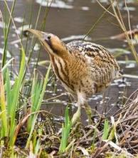  Link to map | Create or manage large reedbeds in wetland habitats to recover Bittern populations.  Within wetlands, create, extend, and manage large reedbeds (ideally of 20 hectares or more) for Bitterns. Re-wet reedbeds that are at risk from drying out and manage the reed structure to achieve diversity within the reedbed. Aim for no more than 30 per cent being older than 7 years and no more than 5 per cent of the area being scrub. Manage the reedbed through cyclical cutting of different sections of reed over time and regularly remove willow.  Bitterns breed in the UK’s largest and least disturbed reedbeds which are typically within a mosaic of wetland habitats. Habitat loss and  disturbance has been a major challenge for the success of these birds and Bittern numbers previously declined to the point where this bird became extinct from the UK. However, they returned and are now  present in the UK again with some populations showing recent signs of recovery as a result of large-scale reedbed creation and targeted habitat management techniques.  Bitterns are found in Oxfordshire but breeding is currently restricted to one locality (Otmoor). They are a bird which is expected to improve in number and breeding success if more large reedbed complexes can be created with the right habitat management. | Otmoor, Lower Windrush Valley | Birds Eurasian Bittern (Botaurus stellaris),  Marsh Harrier, (Circus aeruginosus)

The numbers above (20 hectares, 30 per cent, and 5 per cent) are based on ideal guidelines but management should be tailored to what is working for Bitterns in Oxfordshire.

You can re-wet reedbeds that are at risk of drying out either by raising the water-level, or by lowering the ground level.
Breeding waders  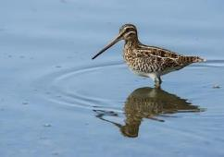  Link to map | Create (and maintain) areas of grassland with extensive, shallow, water during breeding months including reeds and greater pond sedges for nesting. Manage habitats with  grazing (ideally) and exclude and manage predators.  This guide describes how to manage grazing land for waders. Also see this RSPB land management sheet for Snipe.  Typical ideal breeding wader sites have moist soils that hold surface water on approximately 10 – 30 per cent of the site from April/May with water levels reducing in June and covering only a small area of the site in July – August.  Seasonal grazing on these sites helps to create an optimal sward. Avoid agricultural activities or activities of high disturbance on breeding sites during breeding season and consider reducing the shooting of any species considered to be 'game' species within this group to support populations to recover.  Alongside those more specific measures, this LNRS will support these species and others by recommending that Oxfordshire improve existing wetland sites and create new wetland mosaic habitats.  Within Oxfordshire, we are lucky to have 485 hectares of Otmoor, an expansive floodplain grazing marsh area which is a reliable hotspot and home for many species including wading birds where particular care is taken to manage this area of Oxfordshire for these birds. | Otmoor, Lower Windrush Valley | Breeding wader birds: Common Snipe (Gallinago gallinago), Common Redshank (Tringa  tetanus), Lapwing (Vanellus vanellus)  Other birds Common crane (Grus grus)

 | This national asset means that Oxfordshire is a particularly important location within the UK for breeding waders and other species.
Curlew  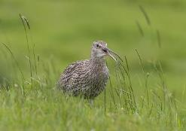  Link to map | Manage nesting fields for Curlews and protect their nests from predation using predator control, electric fencing and/or other techniques which increase Curlew breeding success to hatch, rear, and fledge chicks.  Curlew breeding populations in the UK are recorded as having declined by 48 per cent between 1995-2020 and Curlews are one of Britain’s most endangered birds.  They rely on grassland habitats (particularly lowland wet grassland and hay meadows) but many of these habitats have been lost through land use change and drainage of land.  Alongside extensive creation and expansion of well-managed grasslands, especially lowland wet grassland, predator control techniques need to be implemented to prevent the loss of nesting adults, eggs, and chicks to predators (predators can be both mammals and birds).  Temporary electric fencing is one tool with a good success rate in  Oxfordshire that can prevent mammal predation but other techniques across the wider landscape are important to prevent other forms of predation on these birds to enable them to recover their populations.  Many people, including Oxfordshire’s farmers, nature recovery organisations, and volunteers are already supporting curlew recovery efforts and should continue to be supported to take these actions. | Otmoor, Upper Thames Curlew Recovery Project  areas, upper Cherwell  areas. | Eurasian Curlew (Numenius Arquata) | 

Farmland birds  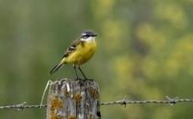  Link to map | Support farmland birds in fields, field margins, and hedges by providing nesting sites, chick rearing food, adult food, and overwinter food for the target bird species.  A good population of farmland birds are present in Oxfordshire, with strong populations noted in farmland across the county, particularly in the Cotswolds National Landscape and the North Wessex Downs  National Landscape. Since more than 70 per cent of Oxfordshire’s land is used for agriculture, it is of key importance to focus on supporting those species which can benefit from good sustainable farmland management to achieve population recovery and Oxfordshire’s farmland birds are a great example of species which, have been recovering and can continue to do so in future with support like that already ongoing by Farmland Bird Aid projects in Oxfordshire.  All three elements (chick food, adult food, and nesting space) need to be appropriate to the species and available in the specific area to suitably support these birds. This can be achieved by providing plants, seeds, and habitat areas that meet the needs of both the adult farmland birds and their chicks, within the same location. The different species have the following, specific needs:  Hedge-nesting birds  Hedges, trees or scrub are needed for nesting. Also offer these additional food sources for adult hedge-nesting birds; seeds, chickweed, cereals or spring-sown crops.  Offer these additional food sources for the chicks of hedge-nesting birds; insects, larvae, worms (often provided by having nearby areas of field margins/buffer strips/grassland/pasture).  Linnet – require a plentiful supply of seeds all year and a thick hedgerow, scrub, gorse or bramble for nesting. Advice for farmers here. | All across the county’s farmland, with a specific 4- mile stretch of the River Thames already under management for the Yellow Wagtail  Partnership. | Farmland birds:  Corn bunting (Emberiza calandra), Grey Partridge (Perdix perdix), Lapwing (Vanellus vanellus), Linnet (Linaria cannabina), Skylark (Alauda arvensis arvensis), Tree sparrow (Passer  montanus), Yellowhammer (Emberiza citrinella), Yellow wagtail (Motacilla flava flavissima)

Tree Sparrows – also need overwintering stubble to find food, and good nearby scrub, thick and tall hedgerows, and/or young woodland cover for nesting. Advice for farmers here.

Yellowhammers – also need thick hedges or scrub (cut late in the year), often alongside ditch vegetation or margins at the foot of the hedge. Advice for farmers here.
Ground nesting birds
Offer suitable, species-specific nesting sites and also offer these additional food sources for adult ground nesting birds; seeds, chickweed, cereals, overwinter stubble, or spring-sown crops.
Offer the following additional food sources for the chicks of ground nesting birds; insects, larvae, worms (needs field margins or buffer strips or grassland or pasture).

Corn Buntings – need patches of double-drilled crop that is not harvested, to nest. Advice for farmers here.
Skylarks - need skylark plots (unsown squares in the field) of bare earth to nest. Advice for farmers here.

Lapwings – need lapwing plots (large stony areas) to nest in, near pasture. Do not plant trees or hedges here. Advice for farmers here.

Grey Partridge – also needs safe nesting cover in hedge bottoms, grass margins, and dead tussocky grass left from the previous year (RSPB).
Adults require a food source of seeds and shoots throughout the year (typically found in winter stubble, harvested root crops, newly sown crops, and arable weeds in the crop margins).

Also, to enable species recovery, chicks require access to a range of insects close to their nesting sites like beetles, ants, caterpillars, aphids mostly found in crop margins. Advice for farmers here.

Yellow wagtails – also need an open, sparse sward to nest in on the fringes of wetland habitats with arable crops nearby.

They are expected to respond particularly well in Oxfordshire if habitat management can meet their needs, and local projects are already working to achieve this. Advice for farmers here.
At some sites, recovery may also require additional lethal control of foxes, carrion crows, and mink in conjunction with the actions above.
Montagu’s Harrier  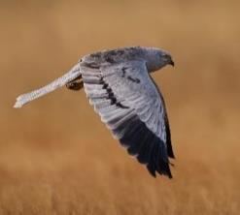  Link to map | Locate and protect the nesting sites of breeding Montagu’s Harriers on farmland fields. Landowners and local organisations can work together to monitor nesting birds and secure their breeding success.  Montagu’s Harriers visit the UK in early summer and only very few (8 pairs) breed in the UK each year. Oxfordshire has 137 records of Montagu’s Harrier in in the past 30 years and Oxfordshire is one of the counties where this species is known to be found breeding.  Typically the birds breed on the ground in arable fields of maturing crops. This bird feeds on small mammals, birds, and other small animals.  When nesting birds are observed, contact local organisations which support bird conservation for support and advice. |  | Montagu’s Harrier (Circus pygargus)

Nightingale  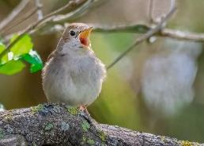  Link to map | Manage woodlands and scrub for Nightingales.  Coppice on rotation and encourage dense layers of shrub in woodlands with scrub at the edges.  Introduce coppicing to woodlands and manage it so that all stages of the coppice lifecycle are always present in the  woodland. To do this, coppice coupes (groups of trees) that are cut on rotation. Within woodlands, encourage dense layers of shrub to develop (including bramble) and control deer where necessary to prevent them from eating the shrub layer.  On woodland edges allow dense scrub and shrubs to develop to offer feeding and nesting habitat and create woodland rides and glades that have space for a scrub zone. Re-wet woodlands to improve invertebrate presence and food supply for these birds. Connect existing suitable habitats with tall, thick hedges.  Nightingales fly from West Africa to the UK in April for about 3 months to breed before flying back. Numbers of breeding birds are thought to have reduced by over 90 per cent since the 1960s.  In Oxfordshire, breeding Nightingales had been lost from the county for 2-3 decades but around 2020 after dedicated habitat work by MOD Bicester, nightingales returned once again, to breed in Oxfordshire. Habitat actions should be focused towards areas where Nightingale records emerge in Oxfordshire and  Nightingales are also expected to benefit from countywide creation of large scrub and woodland mosaic habitats.  Nightingales prefer to nest in the medium growth stage of coppiced trees (aged 4 – 10 years since they were coppiced). It  takes about 7 years for scrub to be sufficiently dense for nightingale breeding. View conservation advice guide here. | Southeast of Bicester, between Bicester and Brill | Common Nightingale (Luscinia megarhynchos) | 

Stone Curlew  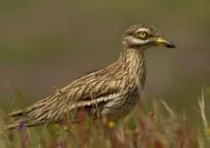  Link to map | Create and manage protected, undisturbed plots to encourage Stone Curlews to nest. Create and manage areas of open, sparsely vegetated grassland with stony ground, grazed short (typically by rabbits or sheep).  In suitable arable fields, create specially prepared plots of open, stony ground with buffer zones that are managed to protect  nesting birds and chicks from predation, machinery, and disturbance.  These plots offer suitable, less disturbed nesting spaces and can be supported by organisations who can also ring and monitor the birds.  Stone Curlew numbers have been in decline in the UK until the 1980s where dedicated conservation efforts more than doubled the breeding numbers and these birds are increasingly present in the UK when habitats are managed to meet their needs. These birds do appear to favour locations where suitable habitat plots are created and managed for them.  Typically, they fly from Spain and Northern Africa to the UK in early summer to breed here on open, stony ground (typically farmland) and farmers can work with organisations to organise this, see an example here.  The success of these birds relies on suitable support being available to enable farmers to recover Stone Curlew populations.  See information about Defra incentives here and recent, successful RSPB projects with farmers here. |  | Stone-Curlew (Burhinus oedicnemus)

Swifts and house martins  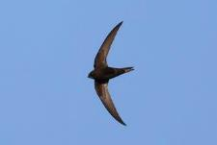  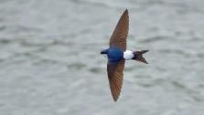  Link to map | Provide new nesting spaces that are suitable for  Common Swifts and House Martins and do not disturb, remove nests, or try to limit these birds from nesting.  Common swift numbers are estimated to have declined by 60 per cent between 1995 – 2020. Similarly the House Martin is present throughout the county but numbers notably declined by 37 per cent between 1995-2020.  Each year, these birds migrate from Africa to the UK for summer to breed and Oxfordshire is a particular national stronghold for these birds with projects that you can get involved across the county (e.g. Oxford, Cherwell, and Harwell).  Both species offer real opportunities for people to support and enjoy nature on (or above) their doorsteps. They nest in and around houses, buildings, and structures but many nest sites have been lost to building renovations.  Buildings act as a habitat for a variety of species but the nest sites of Swifts and House Martins are often lost during the renovation or redevelopment of existing buildings and other structures like bridges.  The loss of these nesting sites has contributed to a decline in the populations of both species but these birds are expected to be able to recover significant numbers if additional nesting spaces are provided (boxes, swift bricks, spaces in buildings and structures), and if existing nesting sites are retained for these birds.  Existing nest sites for building-dependent species such as swifts and house martins (endangered red-listed species) should be  protected as far as possible. These species are known to return annually to their traditional nest sites and mitigation should be  provided if these nest sites cannot be protected. | Swifts; across Oxfordshire, including Oxford City, all the towns in the county, and a majority of villages as well (Harwell,  Bodicote, Shilton and Tetsworth for example).  House Martins; less widespread but still breed throughout the county. | Common Swift (Apus apus), House Martin (Delichon urbicum).

New development and extensions provide an opportunity to includes measures such as swift bricks. Swift bricks are a universal nest brick that can support a variety of small bird species (like house sparrows and starlings) and should be installed in new developments including extensions, in accordance with best-practice guidance such as BS 42021, NHBC NF89

Biodiversity in new housing developments: creating wildlife- friendly communities, or CIEEM which require at least one swift brick per home on average for each development. Artificial nest cups for house martins may be proposed instead of swift bricks where recommended (e.g. by an ecologist).
In addition to nesting spaces, they require good foraging habitats, particularly along rivers, to capture insects. Habitat improvement is being addressed in the LNRS through actions
recommended on the LNRS Statement of Biodiversity Priorities.
Tawny Owl  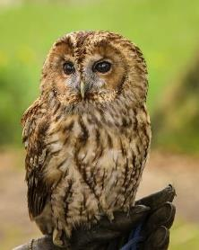  Link to map | Provide nesting holes and/or boxes for Tawny Owls.  Tawny owls and other owl species have experienced declines across England and whilst they require habitat improvements. Whilst they would benefit from general habitat improvements, especially to woodlands, it is also believed that their range and numbers could be significantly supported by offering more, suitable nesting boxes/holes.  Tawny owls can live for over 20 years and often return to their territories and nest holes/boxes throughout their life. This could be in areas where these owls are present or could be present including; woodlands, large urban parks, and suburban or rural gardens (see further information here). |  | Tawny Owl (Strix aluco) | 

Learn how to build or position boxes for Tawny owls (here)

In addition to nest boxes, these species are expected to benefit from the wider creation of a more connected set of habitats, especially woodlands, and have been noted to avoid major roads. This means that the creation of new infrastructure could further fragment Tawny Owl habitats and should be carefully considered within decision making.

The creation or provision of green bridges could be an opportunity to better connect habitats across major infrastructure
(new or existing) which may benefit this species (and others).
Turtle Dove  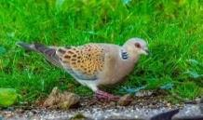  Link to map | In appropriate areas on, or near to farmland, create and manage scrub with trees and habitats that support Turtle Doves.  The UK numbers of breeding Turtle Doves has dropped by 99 per cent between 1967 and 2020 which shows how perilous the situation is for Turtle Doves in the UK.  This species used to be common across farmland and certain farmland practices could greatly benefit the Turtle Doves which fly to the UK from Africa to breed in summer. See how you can help Turtle Doves here. Turtle Dove advice for land managers can be found here.  Turtle Doves typically need 3 key things within close proximity (RSPB recommend within 300m) of each other.  These are:  - Lots of small seeds to be provided as a food source - either as seeds or by planting strips of plants which are left to go to seed.  - Thick scrub, hedgerows, and trees to be created or managed as nesting sites | Otmoor | Turtle Dove (Streptopelia turtur) | 

 | 3. Nearby accessible freshwater like ponds or streams to be created or enhanced offering shallow edges.
Willow tit  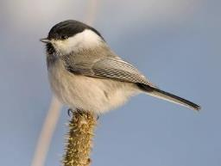  Link to map | Support Willow Tits by linking up wet woodland, dense scrub, and hedgerow habitats along river corridors  with lots of deadwood and stumps.  Retain and create a successive supply of deadwood, such as tall stumps, within and around wet woodland and scrub.  Create structural diversity and promote dense scrub growth near Willow Tit nesting sites through selective felling or the reintroduction of coppicing within damp woodlands. Restore wet woodlands by reversing drainage where suitable.  To improve the stability of Willow Tit populations, link up suitable habitats by creating or retaining scrub lined river corridors and mature hedgerows.  Willow Tits are found throughout the UK but are less common in the South East of England but they are present in Oxfordshire.  The measures above should be considered in addition to the need for good woodland management and the creation of new wet woodlands. When creating tall deadwood stumps, the ideal trees are willow and alder with stumps at least 1.5 metres tall.  Scrub growth around wet woodland should aim to achieve height of 2-4 metres and it may be necessary to control browsing animals to achieve this. Where coppicing is practiced, willow is  preferable over alder. For more information, see the Willow Tit habitat guide. |  | Willow tit (Poecile montanus) | 

Butterflies and moths

Species by  Common Name (ordered A – Z) | Potential measure (the action needed to help the relevant species to recover). Potential measures are in bold with additional detail about the species added below. | Particularly important locations  for the action(s) | Which species are intended to benefit  most? | Habitat
Barberry Carpet Moth  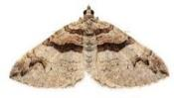  Link to map | Plant new Barberry plants in suitable locations to support the Barberry Carpet Moth. Aim to connect up existing areas of Common Barberry and increase the spread of this plant.  The Barberry Carpet Moth is a rare and declining species in the UK, and is a local priority since one of its largest remaining UK colonies is in Oxfordshire.  The only other known sites are in Wiltshire, with single sites left in Dorset and Gloucestershire. Read more about bringing this species  back here, see their habitat requirements here, and see this guide that explains what a recently funded project did to support this species. | West  Oxfordshire where a small population is established | Barberry Carpet Moth (Pareulype berberata)
Blackthorn butterflies  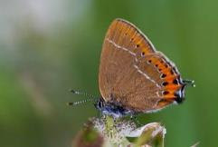  Link to map | Retain, manage, plant, and connect up Blackthorn hedgerows, trees, and scrub for Black and Brown Hairstreak butterflies  Retain existing thickets of blackthorn (Prunus spinosa) and mature blackthorn within hedgerows. Plant new thickets and hedgerows containing blackthorn, especially where they connect to existing blackthorn hedgerows or stands of blackthorn trees or scrub.  Carry out management and coppicing routines for these blackthorn hedgerows, trees, and scrub areas in a manner that suits the Black Hairstreak and Brown Hairstreak. | Oxford City. MOD  Bicester. Hotspot record sites for Black Hairstreak.  Otmoor for Brown Hairstreak | Black Hairstreak (Satyrium pruni), Brown Hairstreak (Thecla betulae)

Encourage blackthorn in and around woodlands where suitable, create wide rides, glades, and scrub edges in and around those woodlands.
In the UK, most black hairstreak butterflies are only found in Buckinghamshire and Oxfordshire making them a priority species for Oxfordshire to support.

The brown hairstreak is also present in Oxfordshire with a strong population in Otmoor that is spreading into Oxford city. The main threat to the success of these species is the damage, poor management, or removal of mature blackthorn habitats.

These rare butterflies would benefit from long-term habitat restoration and creation to maintain and create sheltered (but unshaded) stands of blackthorn which are allowed to spread and grow to about 5 metres in height. These butterflies don’t typically spread far from the blackthorn so the creation of connected blackthorn stands/hedges/trees is key to expanding their populations.

Before winter hedge-cutting or coppicing, try to check blackthorn for eggs. These eggs are particularly vulnerable to hedge-trimming since they are laid on the youngest tips of blackthorn growth.

Consider the importance of Ash trees and retain these trees as long as possible and safe to do so, particularly around known Brown Hairstreak locations. Male and female butterflies congregate on these tall ash trees to mate before then laying their eggs on blackthorn (read more here).

Dark green Fritillary  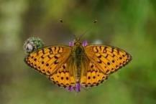  Link to map | Create or enhance suitable flower-rich grassland habitats with plentiful populations of violets and light patches of scrub for the Dark Green Fritillary.  These butterflies can benefit from a few grassland habitats which you can read about here.  These include:  - Chalk and limestone grassland.  - Grassland with bracken  - Damp grassland, flushes and moorland. In all cases, aim to create a plentiful population of violets growing amongst light scrub (if appropriate to the site). Manage scrub and woodland rides to promote violet abundance. |  | Dark green Fritillary (Speyeria aglaja)
 | The Dark Green Fritillary breeds in lightly scrubbed grassland. After a long period of decline in Oxon it has been spreading a little in recent years but remains very localised to suitable habitat.
 | Habitat recovery could see it become more widespread here, see information about its lifecycle and habitat requirements here.
Duke of Burgundy butterfly  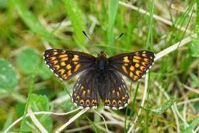 | Create (or maintain existing areas of) scrubby calcareous grassland slopes which face East, North, or West and have strongly growing populations of cowslip and primrose to encourage Duke of Burgundy butterflies.  The Duke of Burgundy butterfly has declined by over 50 per cent in recent decades in the UK and remains in only very small and restricted areas on scrubby chalk grasslands and clearings of ancient woodlands. | One tiny population known to remain in Oxfordshire with some records adjacent to West Berkshire and in West  Oxfordshire. | Duke of Burgundy (Hamearis lucina)
Link to map

In Oxfordshire, one small grassland population is known to remain but woodland populations of this butterfly have been extinct in the county since the 1990s.

See habitat creation and management suggestions here. On grasslands, light grazing (not by sheep) can create open, sunny conditions which support this species.
Within the grassland, aim for 10 per cent - 20 per cent of the area to be scrub of varying ages, types, and structures cut on rotation to avoid overshading the grassland. Allow new scrub areas to emerge. Cut or bruise dense bracken areas.

In woodland near or on these slopes, enhance or create woodland rides and keep or create bare patches of ground.

The butterflies typically breed in vegetation at woodland edges 2 – 5 years after the vegetation was last cut so rotational coppicing of trees at edges or rides over a 3 – 10 year cycle would support these butterflies.
Liquorice Piercer Moth  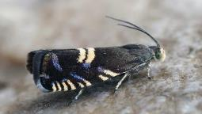  Link to map | Maintain and increase Wild Liquorice plants and their seed pods on suitable rough, unimproved calcareous grassland, lanes and scrub margins for the Liquorice Piercer Moth. Introduce suitable grazing regimes.  Time-limited, light cattle grazing is a beneficial regime to manage the foodplant (Wild Liquorice - Astralagus glycophyllos) for the Liquorice Piercer Moth and support seeds to set where cattle  disturb the ground.  Where grazing is not possible small-scale management should  aim to reduce competing vegetation in and around wild liquorice. Ideally this should be undertaken in late autumn/winter on a | Chilswell | Liquorice Piercer (Grapholita pallifrontana)

rotation so that not all the site is managed in any one year. Remove arisings from the site (detailed guidance here).
Read about a project site being managed for wild liquorice, and other species here.

This Liquorice Piercer Moth is very local to sites in a few southern counties in England and their numbers are declining. However, there are a number of strong colonies in Oxfordshire, particularly in the Chilswell area.

The caterpillar of this moth feeds only on the seedpods of the wild Liquorice plant during July, August and September. As this species has an annual lifecycle, it requires the foodplant to flower and set seed on an annual basis to survive.
Moths of Dyer’s Greenweed  No mapped records | Manage meadows to increase populations of Dyer's Greenweed for moths by preventing scrub and grasses outcompeting this plant.  Manage meadows (particularly older, uncut calcareous meadows and rough pastures) to increase Dyer’s Greenweed plant populations to benefit the Greenweed Flatbody moth.  Grazing and cutting should be managed flexibly according to habitat requirements to support the moths that rely on this plant for survival.  This moth is now rare after significant recent declines in its populations but it is present in and around Bicester and Otmoor MOD meaning that Oxfordshire is still home to a strong population which is regularly monitored by Butterfly Conservation and it may be present at other sites in the area (Arncott MOD, Wendlebury Meads). | Otmoor, MOD Bicester, Cotswolds, Chilterns, Banbury. | Plant: Dyer’s Greenweed (Genista tinctoria)  Moth: Greenweed flatbody (Agonopterix  atomella),moth (Mirificarma lentigosella)

 | Carry out surveys and monitoring in suitable locations to monitor and report moth sightings at sites with Dyer’s Greenweed.
Silver-spotted skipper  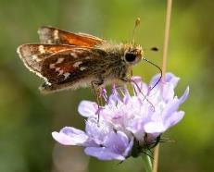  Link to map | Create and manage south-facing calcareous grassland, grazed to extremely short turf with Sheep’s Fescue  growing, to benefit the Silver Spotted Skipper.  The Silver Spotted Skipper is only found in chalk downs in southern England but has good potential to expand its range over the coming years. However, they need sustained habitat management to maintain short turf conditions.  Sometimes this short turf can be achieved through rabbit grazing but, in the absence of sufficient rabbit grazing, recommendations are to implement a rotational grazing regime with sheep or cattle in a manner that doesn’t overgraze the foodplant (sheep’s fescue).  See this guide for more information.  In Oxfordshire, there is one critically endangered small population remaining where management can be targeted. Additionally, if suitable conditions are created elsewhere in the county, consider translocating the Silver-spotted skipper into those suitable sites since natural colonisation is unlikely. | Aston Rowant NNR | Silver-spotted skipper (Hesperia comma)
Small blue butterfly  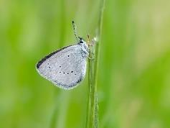 | Create and manage wide field margins and sheltered grasslands to contain Kidney Vetch (Anthyllis vulneraria) on low nutrient soils which get disturbed, to support Small Blue butterflies.  The Small Blue is England’s smallest resident butterfly and requires habitat management to recover their numbers in Oxfordshire. |  | Small blue (Cupido minimus)

Link to map | Oxfordshire is reported to have local populations which are declining but this species is expected to be able to recover if suitable habitats are created and maintained. See this guide about creating bare ground for butterflies.
Striped Lychnis moth  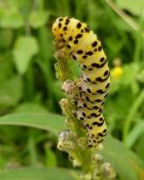  Link to map | Plant (and manage) Dark Mullein on grassland in and around the Chilterns to support the Striped Lychnis Moth.  The Striped Lychnis Moth has been declining since the 1970s in Britain but has a stronghold across the Chilterns National Landscape and appears to be doing well here.  The caterpillars of this moth feed on the plant Dark Mullein (Verbascum nigrum) and some cases have been reported on White Mullein (Verbascum lychnitis) and ornamental mulleins in gardens.  The priority action is to plant and establish Dark Mullein plants on open, sunny grassland habitats like downland, field margins, verges and even in gardens within the Chilterns.  This can be done from seed or from plug plants as needed.  Dark Mullein establishes most successfully where there has been ground disturbance but persists for up to 7 years (possibly more) in open grassland.  The crucial thing is that the grassland must not be mown during the egg-laying and larval periods, which are typically June to August. Management will be needed to limit scrub and to maintain the verges/grassland habitats/gardens that contain Dark Mullein to stay open and sunny to remain successful for Striped Lychnis Moths. | Open, sunny, grasslands (and gardens) in the Chilterns National Landscape | Striped Lychnis moth (Shargacucullia lychnitis)

 | There is a recent report of Moth records here by the Butterfly Conservation (Upper Thames Branch). This action builds on previous projects to spread and manage Dark Mullein which you can read about here.
White Admiral  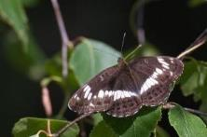  Link to map | Manage woodlands for White Admiral butterflies achieving partial shade with honeysuckle, brambles, and areas of bare ground.  Local White Admiral populations have declined and some have been lost in the past 30 years but the creation of suitable woodland conditions is expected to support populations to re- establish.  See this guide to see what actions to take in existing woodlands and how to create new woodlands where the new habitat could mature into a suitable woodland to support these butterflies to spread in future.  Create and manage woodlands to achieve partially-shaded conditions (not dark) with honey suckle growing in sheltered conditions for White Admirals to lay eggs on. Manage and enhance woodland rides and glades to have zones with bare ground present and allow brambles to grow and flower in large patches to offer nectar.  Consider management through coppicing woodlands on 12 – 30- year rotations, retaining trees which support honeysuckle. Control browsing by deer to promote coppice regrowth and seek to create and connect open areas within the woodland. |  | White Admiral (Limenitis camilla)

White-letter Hairstreak  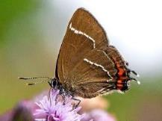  Link to map | Retain Elm trees for White Letter Hairstreaks and plant or grow new disease- resistant Elms, especially within 2km of existing Elm woodlands.  The White-Letter Hairstreak still remains in small populations where elms are present including large, isolated elm trees and hedgerows, scrub, and woodland rides or edges which contain elm.  Many butterflies have been lost over recent decades during the period where many Elms were lost to Dutch Elm Disease. Elm is now a relatively rare tree species and these butterflies need targeted action around remaining or newly planted Elm sites in Oxfordshire to expand and/or connect butterfly populations.  Do not fell mature, healthy Elm trees as a precaution against Dutch Elm disease. Allow Elm suckers to grow where they appear. In areas where scrub or woods show evidence of Dutch Elm disease, introduce coppicing on a 10-year cycle.  Manage hedgerow shelterbelts that contain elm and avoid cutting edges where new elm suckers appear. Enhance rides and glades and create extensive ride and glade networks within woodlands.  Connect habitats with hedgerows containing Wych Elm (Ulmus glabra) as a hedging plant and disease-resistant elms as hedgerow trees. | Elm sites in Oxfordshire | Butterfly: White-letter hairstreak (Satyrium w- album)  Lichen: Orange fruited elm lichen (Caloplaca luteoalba)
Wood White Butterfly | Manage woodlands for the Wood White butterfly and then consider reintroductions of the butterfly to  suitable woodlands.  The Wood White species is reported to no longer be present in Oxfordshire and it is not well understood why. The species is still | Woodlands in Northeast  Oxfordshire close to Buckinghamshire populations | Wood white butterfly (Leptidea sinapis)

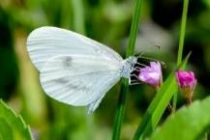  Link to map | present on the Buckinghamshire side of the Oxfordshire’s North- Eastern border meaning that Wood White populations could be recoverable and re-established if woodlands can be managed to achieve suitable conditions.  See a management guide here.  Reintroduce the Wood White butterfly to suitable woodlands and manage woodland ride sides to provide shelter and a tapered edge between tracks and maturing timber.  Consider management through coppice techniques on rotations of fewer than 12 years and create connections between open areas in woodlands.  Supplemental seeding of primary larval foodplants may be necessary eg. Bitter-vetch (Lathyrus linifolius), Common Bird's- foot-trefoil (Lotus corniculatus), Greater Bird's-foot-trefoil (Lotus pedunculatus), Meadow Vetchling (Lathyrus pratensis) and Tufted Vetch (Vicia cracca).

Fish, crustaceans and molluscs

Species by  Common Name (ordered A – Z) | Potential measure (the action needed to help the relevant species to recover). Potential measures are in bold with additional detail about the species added below. | Particularly important locations  for the action(s) | Which species are intended to benefit  most? | Habitat
Desmoulin’s Whorl Snail  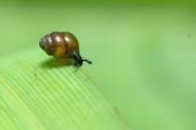  Link to map | Manage sites that have, or could have, Desmoulin’s Whorl Snail to maintain an appropriate vegetation structure.  The Desmoulin’s Whorl Snail is a tiny snail with a very limited international and national range.  The Oxfordshire populations represent a key proportion of the national records and bespoke management is required to support this species. They are typically found in tall wetland grasses, sedges, and reeds in fens, swamps, and marshes that border rivers and lakes. | Cothill, Cholsey Marsh. | Desmoulin's Whorl Snail (Vertigo moulinsiana)
Where this snail is already present, it is important not to significantly change the habitat management at the sites. Instead, the priority aim is to safeguard and maintain the existing vegetation structure through the continuation of previous low-intervention management practices to
prevent loss of this species.
 | They rely on tall wetland grasses, sedges and reeds in consistently damp or wet ground (not dry and not deeply flooded). Aim to retain consistent, high, groundwater levels at the site to provide humid conditions.
 | Also keep the site open and sunny by preventing scrub growth and limit or prevent livestock grazing, mowing, and cutting since heavy trampling or loss of vegetation would eradicate the snail populations.

If possible, consider extending this management out from sites where the snail is present out to adjacent locations to expand the footprint of habitat to support this species.

For more detail, see this guide from Natural England about managing habitats for this species.
Fish  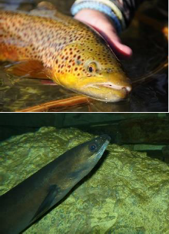  Link to map | Create and maintain fish passes or remove structures within rivers to enable fish to migrate and reproduce.  Remove physical structures that blockade the river (if the blockade is currently redundant and serves no essential purpose).  For structures which cannot be removed, provide bespoke fish passes at these structures along rivers to enable fish to migrate and move between river sections and to access spawning ground (to lay eggs to reproduce).  Fish passages are essential in addition to the more general restoration along more areas of modified river channels to reduce excess siltation by e.g. narrowing over-wide channels and replacing gravel beds, which will provide habitat diversity and improve spawning habitat for a greater diversity of fish species. | Across the county’s rivers. | Brown trout (Salmo trutta), European Eel (Anguilla Anguilla), Grayling (Thymallus thymallus)
 | Eels are a migratory species which spawn at sea but grow on in freshwaters and are experiencing a major global decline in numbers including within Oxfordshire rivers in the past 30 years.
 | Local declines are also noted for Brown Trout and Grayling.
Alongside overall improvement to river quality and river habitat, all fish
also need to be able to move through river systems to access good habitat for breeding and growing, but the legacy of the numerous

structures built on rivers for milling, navigation and amenity has created numerous barriers to fish movement.
Creating fish passes (multi-species passes for trout and coarse fish, and eel passes for eels) would help fish to move between sections of river to access places to reproduce and leave their eggs.

Contact the Environment Agency’s Fisheries and Biodiversity teams who can advise on key locations to provide fish passages and river restoration. Oxfordshire’s local catchment partnerships are also a valuable point of contact.
Mountain Bulin snail  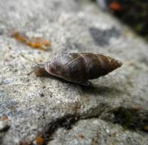  Link to map | Develop a dense, undisturbed litter layer in woodlands, particularly ancient beech woods, and manage them to achieve partial shade for the Mountain Bulin Snail  Manage suitable woodlands to achieve shaded conditions particularly in ancient beech native woodland. Light thinning or selective felling may be appropriate when regeneration of trees or the shrub layer is required.  Minimise the disturbance of the ground, leaflitter, and wet areas within woodland as much as possible. Control grazing to minimise  disturbance, some light grazing may be suitable to control coarse vegetation but can also be achieved through small-scale mechanical means.  Maintain graded woodland margins with site-native trees on external wood-edges. Where appropriate, introduce management through rotational coppice in small coupes, on rotations of more than 12 years which can be highly beneficial to developing the dense litter layer required.  Land snails like the Mountain Bulin Snail are highly sensitive to local disturbance. | Cotswolds and Chilterns | Mountain Bulin (Ena montana)

 | Good woodland management is important whilst following the actions above and generally, longer coppice rotations seem to be more beneficial to invertebrate communities living in the woodland litter.
White clawed crayfish  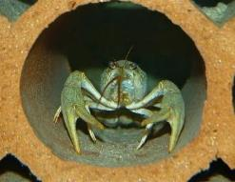  Link to map | Conserve remaining White Clawed Crayfish populations by managing the river habitat and improving water quality. Also look for suitable sites to expand their range.  The UK is thought to support a quarter of the world’s population of White Clawed Crayfish - the UK’s only native crayfish species.  It is under threat due to the spread of American Signal Crayfish (an invasive species) and the disease they carry which quickly exterminates native white clawed crayfish populations. White Clawed Crayfish numbers dropped dramatically in recent years. In Oxfordshire, this species remains in 1 or 2 watercourses as isolated populations.  Without action and support, it is expected that this species will be lost from Oxfordshire and, potentially, from the UK. If future, effective techniques emerge that can exclude American Signal Crayfish, this will be an important action to take but there are no clear methods to achieve this at present.  Oxfordshire should try to conserve the very restricted remaining populations of white-clawed crayfish in the county by ensuring sensitive watercourse management, retention of refuge features for crayfish (cobbles, tree roots), and maintaining and improving water quality.  Oxfordshire should use targeted surveys (potentially using eDNA techniques) on suitable watercourses to monitor whether there  are/could be any other remaining populations of white clawed crayfish in the county. | Chalk and limestone streams in  Oxfordshire. | White-clawed crayfish (Austropotamo bius pallipes)

Suitable watercourses are those without American signal crayfish and which have barriers to colonisation by American signal crayfish. Some survey methods for white-clawed crayfish require a protected species licence.
Any remaining Oxfordshire populations of white clawed crayfish that are deemed to be ‘at-risk’ could be carefully considered for relocation. Consider introducing or translocating White Clawed Crayfish into suitable ‘offline’ sites (waterbodies which are not connected to a river) which are identified as suitable sites away from the risk of competitive American signal crayfish (such safe sites are known as Ark sites).

See habitat management guidance for White Clawed Crayfish here and details about Ark sites and mineral extraction guidance for this species here.

Fungi and lichens

Species by  Common Name (ordered A – Z) | Potential measure (the action needed to help the relevant species to recover). Potential measures are in bold with additional detail about the species added below. | Particularly important locations  for the action(s) | Which species are intended to benefit  most? | Habitat
Fungi and fungi- associated plants found with woodland  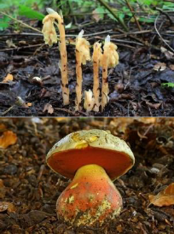  Link to map | Ensure the long-term continuity of suitable tree species with careful management to support rare woodland fungi and plants.  Retain trees where these plants and fungi are found. Ensure the long- term continuity of suitable tree species in these locations (saplings through to veterans) through planting or encouraging regeneration. In hotspot areas of these species protect soils by avoiding felling or coppicing trees and avoid fires, fertilisers, and using heavy machinery.  Avoid mowing during peak fruiting/flowering periods and control vegetation competing with the target species. Control deer and limit  scrub and bramble encroachment. Consider fencing off populations of these species where necessary.  To increase the population of these species, create new areas of suitable tree species adjacent to the sites where these species are currently found.  These plants and fungi may be found in a range of habitats including woodlands, parkland, hedgerows. Oxfordshire is a particular stronghold for these species found amongst the ancient and veteran trees which have been retained and well-managed (sites like Blenheim, Aston Rowant, and Headington). | Various records exist around the county including for fungi at Blenheim, Aston Rowant & Headington. | Flowering plants: Bird's-nest  Orchid (Neottia nidus-avis), Narrow-lipped Helleborine (Epipactis leptochila), Yellow Bird's- Nest (Hypopitys monotropa) and its subspecies (Hypopitys monotropa subsp.  Hypophegea), White Helleborine (Cephalanthera damasonium), Ghost orchid (Epipogium aphyllum).  Fungi:  (Boletus aereus), Devil's

 | These ancient and veteran trees have long-established soils that still support populations of these now rare species and expansion needs to start from sites where these species are present. |  | bolete (Boletus satanus),
Lichens  (on veteran trees)  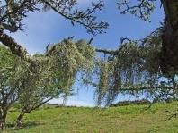  Link to map | Retain veteran trees which host rare lichens and manage woodlands and trees to increase future lichen populations.  Selectively thin trees around veteran trees that host lichens to open overstocked woods and create structural variety.  In lichen hotspots, control the regeneration of young trees to maintain an open wood structure through actions such as reintroducing grazing where historically lost, paying consideration to grazing pressure from wild herbivores.  Consider creating glades around the woodland that vary in age and size. Reduce local air pollution levels to as low as possible, including reducing intensive agricultural practices locally to enable lichens to survive.  This action is important alongside broader good woodland management (including the control of invasive species like rhododendron and to create and retain deadwood). Look for opportunities to reconnect existing populations of lichens through pasture, tree, woodland, or hedgerow creation.  Lichens are an excellent indicator of good quality, clean air so measures taken to support this species are also measures which can improve air quality for people and the wider environment (e.g. reducing local air pollution levels).  To best support these lichens, Forestry Commission advise creating glades through approximately a third of the woodland area. | Usnea  articulata (only in Nettlebed common) | Lichens; (Bacidia incompta), (Buellia hyperbolica), (Lecanora quercicola), (Lecanora sublivescens), (Usnea articulata)

Insects and spiders

Species by  Common Name (ordered A – Z) | Potential measure (the action needed to help the relevant species to recover). Potential measures are in bold with additional detail about the species added below. | Particularly important locations  for the action(s) | Which species are intended to benefit  most? | Habitat
Beetle of Autumn Gentian  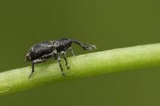  Link to map | Manage existing populations of Autumn Gentian and where suitable, create new areas of Autumn Gentian, allowing the range and population of the Autumn Gentain beetle to expand.  This beetle reproduces by producing larvae in the roots of Autumn Gentian (Gentianella amarella), a late flowering plant which favours dry, chalk grassland.  The plant itself is relatively common across southern England but the populations of this beetle are rare and populations do exist in  Oxfordshire including Aston Rowant NNR. | Aston Rowant NNR | Beetle: (Smicronyx reichi)  Flowering plant: Autumn Gentian (Gentianella amarella)
Cigarello Gall-fly  Link to map | Manage and cut reedbeds on long rotation and prevent scrub and trees from invading, to support the Cigarello Gall-fly.  After being absent from records in Oxfordshire for at least 30 years, the Cigarello Gall-fly was recently found and recorded in Oxfordshire’s Chilswell Valley.  They need targeted and tailored habitat management of reedbeds to support the species to survive. | Chilswell Valley | Cigarello gall- fly (Lipara similis)

Clubbed general soldierfly  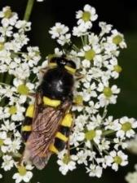 | Ensure that alkaline tufa spring-fed fens in Oxfordshire have a flow of clean calcareous spring flow into the fen and graze, or cut and rake vegetation to keep open, short, sunny pools to support Clubbed General Soldierflies.  The only records of this soldierfly in England are in Oxfordshire meaning we have a key role in preventing the loss of this species through targeted habitat management including ensuring that clean aquifer water continues to feed the habitats which are found to support these species.  If population size and health allow, consider reintroductions of the soldierfly to suitable fen sites. | Cothill fen SSSI and Dry Sandford pit SSSI,  potential for reintroduction to suitable fen sites like Lye Valley | Clubbed general soldierfly (Stratiomys chamaeleon)
Link to map
Dung specialists and dung beetles  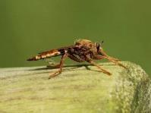  Link to map | Graze pastures with unmedicated animals to supply  unmedicated dung to support rare dung specialist species and dung beetles.  Ensure the continuation of this unmedicated grazing and management on sites where unmedicated animal grazing has been long-established and introduce it to adjacent sites. Additionally, introduce this grazing management to new sites across the county.  This action particularly applies to horses and cattle not treated with anthelmintics, to produce dung that enables rare species to survive and spread including the Hornet Robberfly and dung beetles like the Violet D’Or beetle. |  | Hornet Robberfly (Asilus crabroniformis), and dung  beetles including the Violet Dor Beetle (Geotrupes mutator). | 
 | A paper about Hornet Robberflies and habitat management to support them can be found here with a detailed resource here. See information here about helping ‘Dung Beetles for Farmers’.
 | Many beetles like dung beetles are threatened by the loss of permanent pasture (being disturbed or converted to another use), the

cessation or change in routine of grazing animals, a lack or change of dung supply, and the use of parasite medications (endectocides) as a routine treatment for livestock (Natural England report) found here.

Many medications are used to keep livestock healthy. However, there is rising evidence about the negative impact of Avermectins on wildlife and the environment.
The toxins build up in the dung, soil, and water with negative effects on plants and soil invertebrates like dung beetles. The dung itself also contains significant amounts of the toxin which impacts dung- dependant species. However, there are non-chemical and reduced- chemical options available to farmers, read more here.
Ellipteroides alboscutellatus  No mapped records | Increase the presence of the moss (palustriella commutate) in tufa springs with open woodland. Moss growth could be encouraged by managing woodland to achieve consistent, partially shaded seepages along tufa springs.  This fly relies on the presence of this moss for survival and the fly itself is a very rare species with fewer than 20 records in England at the time of writing with a recent record in Worton Wood, Oxfordshire. If the woodland is suitable for coppicing, this could be introduced to achieve partial shade conditions. | Worton Wood | True fly (Ellipteroides  alboscutellatus)

Lousewort flea beetle  Link to map | Conserve, manage, and enhance suitable areas to increase populations of Marsh Lousewort for the Lousewort Flea Beetle.  Marsh Lousewort is a rare plant which can be found in alkaline fens. The Lousewort Flea Beetle requires this plant to be able to breed. In Oxfordshire this beetle is only known to be present in Cothill Fen SSSI.  See information about the plant here. | Cothill fen SSSI | Lousewort flea beetle (Longitarsus holsaticus)
Meadow ant hoverfly  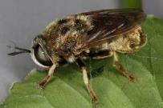  Link to map | Manage grasslands that are good quality, warm, sunny, and open to encourage and retain yellow meadow anthills  (mounds). Graze to a short sward using suitable species like sheep to support the Meadow Ant Hoverfly.  This hoverfly lives in the ant nests (mounds) of 'Lasius flavus' (yellow ants) which need good quality grassland.  In sites that already have the yellow ant mounds, mange the site through grazing and avoid damaging the anthill (mounds) with machinery. In suitable grassland reversion projects, consider the reintroduction of yellow ants if they have not, or are not likely to, naturally colonise the area. | Aston Rowant NNR,  Barracks lane meadow. | Meadow ant hoverfly (Microdon devius)

Noble Chafer  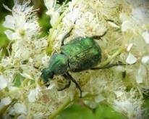  Link to map | Manage and create orchards with deadwood to support Noble Chafer beetles.  A rare metallic-green beetle which can be found in traditional orchards. Support Noble Chafer populations by keeping mature, large, dead, dying, and decaying wood within traditional orchards where this species is present or could become present.  Avoid removing or burning deadwood from these areas and keep mature, suitable tree species in and around the orchard. Introduce Chafer boxes to create temporary habitat for Noble Chafers whilst an orchard establishes and/or sufficient deadwood is supplied.  Plan to grow a future succession of trees that will become mature. For orchard creation, consider using early-maturing varieties of fruit trees.  See this set of facts, survey tips, and management advice specific to Noble Chafers and orchards.  There are six records of Noble Chafers in Oxfordshire in the past 30 years showing that this is a species right on the brink of being lost from the county (and the country). The Noble Chafer relies on dead and dying wood for it’s young (larvae) to survive in, particularly on orchard trees.  The larvae feed on deadwood for up to three years before the adults emerge as a beetles for six weeks in summer to reproduce. Adult beetles are known to choose the nectar of hogweed and meadowsweet which can be encouraged or grown around the edge of orchards to provide nectar sources to attract or support noble chafers beetles.  Use techniques to retain, increase, and prompt new deadwood each year in orchards where noble chafers are known to be present or could be present in future (e.g. through translocation). | Very  restricted to traditional orchards and gardens with mature and declining fruit trees. | Noble chafer (Gnorimus nobilis)

 | Ensure the longevity and presence of large, mature, veteran, and dying trees within the orchard and alongside orchard trees consider planting nearby oak and beech which can also support Noble Chafers.
Snail killing fly  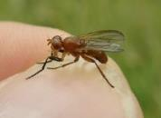  Link to map | Continue extensive grazing management (or cutting and raking) over suitable large areas to keep wetlands short and open throughout the year. Retain or create pools in open wetlands to host snails for this fly.  This fly is found in very few locations in England, one of which is  Oxfordshire’s Port Meadow. It is of key importance to extensively graze these open wetlands and to create areas on the site which can host snails (which this fly relies on to survive).  Other species are also expected to benefit from this open wetland with nutrient rich mud and pools. | Port Meadow | Snail killing fly (Sciomyza dryomyzina), Marsh Dock (Rumex palustris)
Southern Damselfly  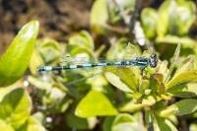  Link to map | Create unpolluted, shallow streams to support Southern Damselflies.  Manage sites where Southern Damselflies are known to be present or could become present to create unpolluted, base-rich shallow streams with a constant moderate flow rate of water and relatively high-water temperatures. Maintain open banksides with unshaded streams.  Endangered in England and at risk of extinction globally, Southern Damselflies remain in the UK in approximately ten areas including one location in Oxfordshire, Dry Sandford Pit. This species requires channels with a permanent flow of water which does not dry out or freeze.  They occur in heathland streams, water meadow ditches on chalk habitats, and fen habitat. | Dry Sandford Pit | Southern Damselfly (Coenagrion mercuriale)

 | See the management handbook for Southern Damselfly for further, detailed action.
Spider  (Tuberta maerens)  Link to map | Create new areas of connected coppice with standard trees including oaks (Quercus robur) especially in and around Brasenose Wood, to support the spider (Tuberta maerens).  This spider is reported to be highly specialised to managed habitats and its range is greatly limited to Oxfordshire, Dorset, Berkshire and Wiltshire.  Whilst the exact, ideal management actions aren’t fully clear, the greatest abundance of this species was associated with oak trees  (Quercus robur) in a coppice-with-standards woodland 12 years after coppicing.  The spiders were particularly found on the South and West facing areas of the tree trunks. | Brasenose Wood | Spider (Tuberta maerens)

Mammals

Species by  Common Name (ordered A – Z) | Potential measure (the action needed to help the relevant species to recover). Potential measures are in bold with additional detail about the species added below. | Particularly important locations  for the action(s) | Which species are intended to benefit  most? | Habitat
Bats  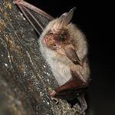  Link to map | Design, create, and enhance wildlife corridors to support bats (in both urban and rural areas).  Survey areas for bats in urban and rural areas to identify bat corridors. Bats use corridors through the natural environment to move (commute), feed (forage), and get to their roosts.  Often, they use tree-lined corridors, hedgerows, woodland, and trees in gardens and greenspaces to move through both rural and urban  areas. Ponds, rivers, and watercourses also help to attract insects that bats feed on and can be a key part of the foraging corridors.  Minimise loss or damage to existing bat corridors, and enhance existing wildlife corridors and features that support bats.  Where possible, create new corridors, habitats, and features in suitable locations that better support bats to forage, commute, or roost. New corridors could aim to connect to existing hedgerows, woodlands, lines of trees, trees in gardens and greenspaces. New corridors can act as stepping stones to help mobile species move through urban and rural areas  However, these species are known to be negatively impacted by lighting. Read more about the impacts of lighting and what you can do | Horspath Tunnel

to help bats here. Care should be taken to minimise or shield lights to benefit bats (and other species) in rural and urban areas.

Get in touch with Bat Conservation to get help with bat-friendly gardens, monitoring bats, and more. For local advice, information, and support, get in touch with Oxfordshire Bat Group.

When designing changes to the environment to create or enhance urban areas and buildings – see this detailed guide, by Bat
Conservation to create an urban environment that can support bats and biodiversity.
Bats (woodland specialists)  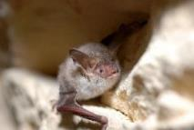  Link to map | Manage woodlands for bats. Typically, retain deadwood and mature trees with dark, humid conditions with well- connected foraging/commuting corridors nearby.  There are 18 bat species in the UK, 14 of which were recorded in  Oxfordshire between 2019 – 2023. In 2024, a very rare, almost extinct species of bat was also found in Oxfordshire’s woodlands –  Bechstein’s bat.  This bat, and the others listed (right) are strongly associated with woodlands and need particular types of woodland management to support them. See this link by Bat Conservation Trust to see the bat woodland specialists.  Survey bats in rural areas and identify woodlands where bats are  present or roosting and report sightings to the Environmental Records Centre TVERC.  Maintain the woodland and surrounding area to support any bat species that are already present (see the needs of different species here). | Bernwood, Tackley Woods, Begbrooke Woods |  | 

Generally, in woodlands aim to retain mature, dead, damaged, and dying standing trees, especially trees with cracks, loose bark, ivy, and holes (or hollows).

Maintain dark, humid conditions around these trees through management such as growing out understory layers, creating woodland ponds or blocking or slowing the flow of drainage ditches. Create foraging corridors across the county (particularly if there are known bat roosts nearby) by planting trees, hedgerow, or woodland.

For detailed information about bat actions in woodlands, see this guide.
Beaver  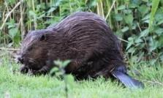  No mapped records | Reintroduce beavers into suitable locations where they are given space and time to naturally restore river diversity and wetland ecosystems.  Beavers are a native UK species but they have been extinct from England for several centuries. In recent decades, some were allowed to come to England in enclosures but there have been no confirmed beavers in Oxfordshire for approximately 400 years.  However, as of 2025, wild releases became legal in England and Natural England will now consider applications for the wild release of beavers.  They will require sufficient evidence of the suitability of the location and the reintroductions are subject to national policy and licensing. The focus of reintroductions should be to promote biodiversity as well as wider benefits that beavers can bring. For example, beavers can create resilient wetland habitats which can store and hold water.  These wider benefits include mitigating damage during flood events and drought events because they can create resilient wetlands that  store and hold water benefitting both people and biodiversity.

 | Beaver habitats have also been shown to improve water quality in areas where they live. Since beavers are now starting to be released into the wild, a plan for their management will be important to ensure that they live well, maximise benefits, and limit conflicts with people.
Hazel dormouse  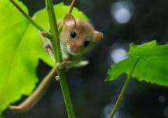  Link to map | Create, manage, and enhance connected corridors of coppice, woodland, and hedgerows to support Hazel Dormice.  Hazel dormice are unable to spread far from their current locations or from reintroduction sites without directly connecting habitats.  Within 1km of sites where Hazel Dormice have been recorded or could become present, create and/or enhance a suitable network of connecting habitats e.g. coppice, woodland, and/or thick hedgerows (these should connect to the original site where the Hazel Dormouse was recorded).  Retain trees which have cracks, crevices, and deadwood and retain woody species like blackthorn and hazel in sunny, open areas.  Ensure that there are arboreal connections across woodland rides at least every 50-100m and erect dormouse boxes and/or tubes to encourage nesting opportunities.  Retain woodland understories in winter and avoid clear felling in known dormouse locations. Consider managing woodland through traditional coppice of non-adjacent coupes. of sites where Hazel Dormice have been recorded or could become present, create and/or enhance a suitable network of connecting habitats e.g. coppice, woodland, and/or thick hedgerows (these should connect to the original site where the Hazel Dormouse was recorded).

Retain trees which have cracks, crevices, and deadwood and retain woody species like blackthorn and hazel in sunny, open areas. Ensure that there are arboreal connections across woodland rides at least every 50-100m and erect dormouse boxes and/or tubes to encourage nesting opportunities. Retain woodland understories in winter and avoid clear felling in known dormouse locations.

Consider managing woodland through traditional coppice of non- adjacent coupes.

Hazel Dormouse populations are estimated to have fallen by 52 per cent since 1995 and are a species that are at risk of extinction in the UK.

It requires the above specific measures as well as good woodland management techniques (see this management guide) to improve the structure and diversity of woodlands.

Within conifer plantations, maintain the margins of deciduous trees and shrubs beside rides, glades and edges.
For more detailed woodland management information, please see the English Nature management handbook for dormice conservation.
Hedgehog  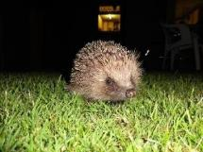  Link to map | Manage gardens, parks, urban environments, and new developments for hedgehogs.  In gardens, parks, urban greenspaces, and new developments, reduce or stop the use of slug pellets and pesticides, create 13cm x 13cm holes through fences and walls to create ‘hedgehog highways’ to help hedgehogs move through gardens and greenspaces to forage and mate. Create or install ‘hedgehog houses’ that provide  undisturbed, safe space for them. | Hedgehog roadkill hotspots, new development s

Sweep fallen leaves into permanent leaf stores where they may take shelter, and manage grass in gardens and parks to create a mosaic of long grass, short turf, open soil, and tussocks where they may search for food like beetles, caterpillars and earthworms.
Hedgehog numbers have declined greatly. They used to be a common sight in both rural and urban areas.

In addition to the more urban actions above, the rural hedgehog populations are expected to benefit from broader, general habitat improvements including the creation and good management of hedges, scrub, woodlands, deadwood, and grasslands as well as increasing regenerative farming practices.
Wider actions to support hedgehogs can be read about here which would also support a range of other species.

Otter  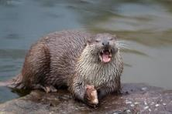  Link to map | Prevent otters from drowning in traps by ensuring that any fish and crayfish traps being used are legally compliant and have properly-fixed otter guards.  Otters are still considered ‘near threatened’ with extinction globally, and their population numbers are impacted by human-caused mortality (e.g. being caught in traps).  Although the use of nets and traps is a regulated activity by the Environment Agency, it is important that the numerous fishing clubs and syndicates ensure that all use of such traps on their waters are compliant with the law to avoid otter mortalities. | Countywide
 | In locations where there are regular otter roadkills, consider adapting infrastructure to improve their chances of survival as they move across land and watercourses.  Otter populations have been recovering in Oxfordshire in recent decades but their populations can be vulnerable to the impacts of human-caused mortality (e.g. roadkill).  Developers, local authorities and National Highways are best placed to implement measures (such as the provision of ledges and underpasses and the use of barrier fencing) to reduce the risk of otter roadkill at hotspots, and the Environment Agency can advise on where the several Oxfordshire hotspots are.  In addition to the actions above, Otters and other species require safe and secure breeding and resting sites, which can be provided by the protection and general improvements to riverside habitats which are already measures that the LNRS is promoting.  There is information for landowners and woodland owners for otter habitat management. Developments and planners should also use  available information to support otters. | Otter roadkill hotspots (information can be requested from the Environment Agency)

Water vole  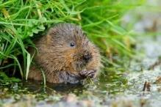  Link to map | Manage (or enhance) riverside banks, ditches, and watercourses for Water Voles.  This action can be to support existing Water voles, or to create suitable habitat for new water voles to colonise. Manage riverside  banks, ditches, and watercourses to create or maintain areas of sunny shallow water margins with marginal and bankside vegetation and avoid excess or extensive overshadowing of the water by scrub or trees (especially if water vole colonies are already present).  Avoid trampling or intensive grazing along the watercourse edge which can damage water vole burrows. Ensure that American Mink are being controlled with the aim to achieve their exclusion where water voles are present.  Water voles have experienced drastic declines in the UK. Their numbers dropped by almost 90 per cent between 1989 - 1998 but water voles can still be found in the banks and waters of Oxfordshire’s fens, rivers, streams, and ditches.  They are most commonly found in areas of slower flowing water with abundant vegetation and steep sided banks (for burrowing into) that have small ledges at their base. Effort should be made to improve habitats where the remaining populations could be joined up with each other.  Alongside improved bank and ditch management, it is key to control the (invasive species) American mink which predate on water voles in an unsustainable manner and cause local extinctions which have driven the decline of this species. Water vole recovery is primarily based on whether the efforts to control American Mink are successful.  Mink were introduced to the country and are the primary cause of the decline of water voles. Water vole projects, like that of BBOWT, bring | Areas that bridge a gap between existing populations

together habitat restoration and mink management and have played a major role in safeguarding Oxfordshire populations.
Improved monitoring and trap-alarm systems now provide an opportunity to create a mink-free Oxfordshire if sufficient resource and support can be found.

To support Water Voles, see management factsheets, handbooks, conservation handbooks for water voles, advice for landowners, and advice for planning decisions.

Plants, flowers and trees

Species by  Common Name (ordered A – Z) | Potential measure (the action needed to help the relevant species to recover). Potential measures are in bold with additional detail about the species added below. | Particularly important locations  for the action(s) | Which species are intended to benefit  most? | Habitat
Black poplar trees  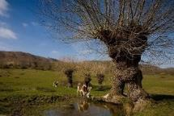  Link to map | Plant or enable Black Poplars to grow in Oxfordshire and retain dead and dying poplars where they have been  growing. Retain deadwood where possible.  Black poplar trees used to be commonplace across England but are now few and far between. The black poplar is considered to be Britain’s rarest tree species associated with wet woodland and forested floodplain. One cause of the decline for this wetland tree was the extensive draining of agricultural land across the country.  Now that there are so few black poplars left, it is unlikely that they can pollinate each other due to the distance between the trees. Careful propagation and planting should be undertaken to grow male and female black poplars close to each other where their seeds can land on damp ground. In this way, population numbers may start to recover. | River Thame catchment | Fly: True fly (Solva marginata)  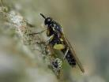  Tree: Black Poplar (Populus nigra)
 | Oxfordshire used to have strong populations of this tree since it grows particularly well in wetlands, floodplains, and near ditches. The tree itself supports a wide range of other rare species. Efforts to plant new black poplars could be targeted near to the remaining black poplar trees in Oxfordshire as well as other wetland sites in the county that are suitable to support the growth of new black poplars.
 | See a Black Poplar action plan here.
 | Avoid removing or burning the deadwood of any remaining black

poplars where practicable and possible (accounting for public safety and access).
This deadwood itself offers a very rare habitat to other species which are at risk of extinction like the true fly (Solva marginata) which breeds under the bark of live, dead, and dying poplars. It requires dead, dying, and rotting poplar trees to be kept in the environment, not removed or burned. For this species it would be particularly beneficial to plant new suitable poplar species in locations near to mature, dead, and dying poplars to ensure a local new source of aging poplars.

A local initiative to restore black poplar populations would greatly support the recovery of these trees. Examples include projects for native Black Poplars in Herefordshire and Dorset often offering free trees to expand the UK’s populations.
Creeping Marshwort  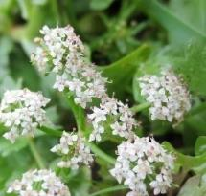  Link to map | Within appropriate floodplain habitats, recover Creeping Marshwort by maintaining and creating damp grassland on the margins of ponds that flood in winter. Maintain consistently short, sparse vegetation through regular, extensive grazing.  Local information about Creeping Marshwort can be found here with a description of the plant here. This plant grows in wet, heavily grazed, grassland that floods in winter.  Suitable sites are typically by rivers however Creeping Marshwort is now very rare with the UK’s main population found only in Oxfordshire. Plantlife and Freshwater Habitats Trust suggest that there are only 2 other smaller populations in the UK.  On sites with Creeping Marshwort, it is essential to mimic or implement heavy year-round grazing by cows or horses. If, in Oxfordshire, the grazing pattern is lost, if the land use changes  significantly, or if the habitats are damaged or under-managed, the species is at great risk of being lost from the UK. | Oxford Meadows SAC (Port Meadow), and a recent reintroduction s to Willow Walk Meadow (Oxford), Lye Valley, North Hinksey, Mill Meadow, Henley,  Cutteslowe (Cherwell floodplains). | Creeping marshwort (Helosciadium repens)

 | Oxfordshire’s sites represent key, national populations of this endangered plant and maintaining a bespoke management regime is a necessary requirement to recover populations of this species. This is also true for sites where Creeping Marshwort is (re)introduced.
Devil’s bit scabious  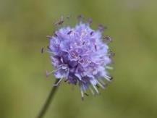  Link to map  (showing Marsh fritillary locations to target Devil’s bit scabious actions) | Enhance existing areas of Devil’s bit scabious and create new large areas in suitable, large habitats. In suitable sites, reintroduce Marsh Fritillary butterflies.  Propagate, plant, and establish Devil’s-bit Scabious to create extensive patches of this plant (throughout the year, including winter) and introduce or maintain appropriate grazing or other suitable techniques that support this plant species.  Where suitable, reintroduce Marsh Fritillary butterflies to areas which have very large populations of Devil’s-bit Scabious. The Marsh Fritillary butterfly has become locally extinct due to habitat loss.  It relies on well-managed, very large areas of grassland (e.g. wet meadows and calcareous grasslands) which contain Devil’s-bit scabious and are appropriately grazed. Guidance suggests that good habitat should exceed 70 hectares with at least 20 per cent of the area containing three or more Devil’s bit scabious plants per square metre.  To support this butterfly, Devil’s-bit Scabious needs to be retained on large sites including adequate areas retained throughout winter.  Extensive grazing regimes are ideal to support this.  Devil’s-bit Scabious creates no seedbank which is why it requires regular, consistent management to maintain its populations and avoid losing both the species mentioned here. | Existing sites of Devil’s bit Scabious Otmoor, Cothill Fen NNR, Lye  Valley SSSI, Yarton Mead, Long Mead. | Devil's-Bit Scabious (Succisa pratensis), Marsh Fritillary (Euphydryas aurinia).  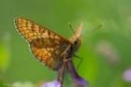  Moths: Narrow- Bordered Bee Hawk Moth (Hemaris Tityus),  Fungi Devil's bit Wart, (Synchytrium succisae), Devil's bit anther smut,  (Microbotryum succisae)

Downy Woundwort  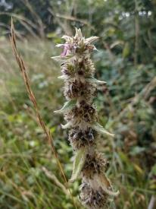  Link to map | Undertake management to increase the presence of Downy Woundwort.  Support existing populations of Downy Woundwort and previously populated areas by managing woodland edges, rides, glades, roadside verges, and hedgerows to limit competitive vegetation growth and create suitable soil disturbance to help this species to spread.  Clear scrub on sites where this species has previously grown.  Perhaps England’s most endangered native wildflower, this species of flowering plant has only been recorded in four sites in England since 1930, all in West Oxfordshire meaning that Oxfordshire has a particular responsibility to try to recover this species.  It has been noted to grow along tracks, ancient pathways, and woodland and hedgerow edges on thin disturbed soil above oolitic limestone.  In one of those four sites, the most recent survey found one plant. The species relies on its long-lived seed which can survive in the soil for many years. Therefore, the actions to help recover this species include causing soil disturbance to places where there may have previously been downy woundwort populations.  Habitat management suggestions can be found here (p67) and here. | Burford and Charlbury. See  Distribution map and page 62 of Wats17p59.p df (bsbi.org.uk) | Downy Woundwort (Stachys germanica)
Fen violet | Maintain populations of, or (re)introduce, Fen Violets at suitable sites.  There are only three known sites where the Fen Violet remains in England. One is Otmoor in Oxfordshire (described here). There is a high threat of national extinction to this species and there is ongoing work by local people and Freshwater Habitats Trust to recover the populations of rare plants including Fen Violet. | Otmoor, and sites where this species has previously been present | Fen violet (Viola stagnina)

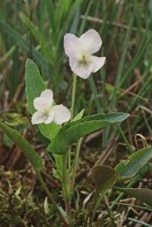  Link to map | Existing sites should be managed to the benefit of this species and to appropriately expose any historic seedbanks. Suitable fen or marsh sites should be considered for (re)introduction of this species to increase its distribution. Possible sites could include areas where the plant was historically present, or they may be new sites.  Consider contacting Freshwater Habitats Trust and Oxfordshire Flora Group to request advice about this species including management or (re)introduction.  Winter inundation with waters down in spring, flowering and setting seed before vegetation gets too tall for it in summer. Careful grazing management is key to enable it to succeed.  Focusing on existing sites to then increase population sites and abundance outward from these sites (particularly around Otmoor).

Greater Water- Parsnip  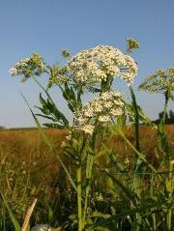  Link to map | Propagate and translocate Greater Water Parsnip out to locations to restore its historic distribution in Oxfordshire.  Greater Water Parsnip was once abundant in Oxfordshire's rivers and floodplains. However the abundance of this plant has declined rapidly in the past 200 years as a result of water pollution (eutrophication), wetland drainage, and inappropriate ditch management.  The plant requires enough disturbance and grazing to avoid the area scrubbing over but not so much that the plants are all eaten and the habitat trampled. Propagate this plant and support translocation efforts into suitable wetland and riparian sites with a suitable balance of management or grazing for this species.  Get in touch with Freshwater Habitats Trust to find out more about what’s best for this species.  Suitable habitats for translocation are: fens, and emergent and fringing vegetation by rivers, streams, canals, ditches, lakes and ponds. This guide can give you more information about identifying the plant and understanding its range and habitat requirements. |  | Greater Water- parsnip (Sium latifolium)

Juniper  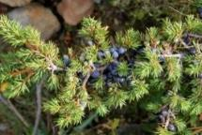  Link to map | Regenerate Juniper and manage sites to recover Juniper populations.  Regenerate and increase the presence of Juniper by creating scrapes down to bare soil to establish the seeds and then manage the area for Juniper (and associated species). Where necessary to benefit Juniper regeneration, exclude rabbits, deer, and sheep from these areas.  Mature Juniper colonies have been dying out in lowland England and have not, by themselves been naturally regenerating any new young Juniper with any success in the past 60 years.  Without Juniper regeneration projects this plant is expected to go extinct within the next 50 years from lowland England. Oxfordshire is one of a few counties which have key suitable areas of southern chalk grassland where Juniper could be re-established, and work is being undertaken to better understand and develop natural regeneration methods to prevent the loss of Juniper and dependent species form Oxfordshire.  Bare earth, ruderal plants (plants which colonise bare ground), and invertebrates are a particularly important components of chalk and limestone grasslands which will also benefit from juniper scrapes.  Species which are likely to benefit from Juniper projects include rock- rose, wild thyme, horseshoe and kidney vetch along with several species of blue and skipper butterfly. | Aston Upthorpe and Aston Rowant NNR | Juniper (Juniperus communis), Moth (Argyresthia praecocella)

Limestone fern  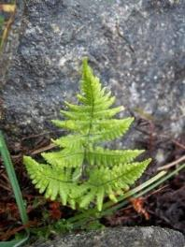 | Create new areas of bare limestone in woodlands, along rivers, in walls, built structures, and gardens to encourage Limestone Ferns.  The creation of limestone structures like dry stone walls, buildings, bridges can support this species as can techniques to expose patches of limestone soils and rock in areas of suitable habitat.  The creation of bare patches should not aim to eradicate large areas of other existing habitats but should be conducted in a complementary manner to add biodiversity value to sites where this species could colonise the cracks or scree in limestone rock and exposed areas of limestone-rich soils. | West  Oxfordshire, the Cotswolds, North of Bicester, and East of Watlington. | Limestone Fern (Gymnocarpium robertianum)
Link to map | The creation of new areas of exposed limestone will be required over time to maintain a population of this species.
Long-Leaved Helleborine  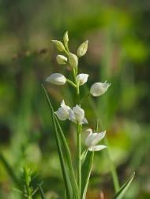  Link to map | Maintain permanent areas of suitable glades, rides, or open spaces within woodlands where long-leaved  helleborine are present.  Create and/or enhance glades and open spaces (like wide rides) within suitable woodlands to create permanently light areas within the woodland. Retain a few trees or shrubs in open areas to avoid exposing these plants to too much light as they can be prone to drying out.  Manage and control competing vegetation (particularly in the permanently open areas). Vegetation control with occasional soil disturbance in open areas can be achieved through time-limited grazing by suitable animals or other suitable methods. |  | Long-Leaved Helleborine (Cephalanthera longifolia)
No recent records | This helleborine is associated with ancient or mature calcareous woodlands where the plant has been found. This plant does not  enjoy changing conditions and benefits from permanent open, sunny

areas in woodlands with enough shade to avoid drying out. Similarly, the land should be moist and not waterlogged or dried out.
Typically, cattle or horses are used for grazing in a time-limited manner to thin competing vegetation and cause slight soil
disturbance without compacting the soil or overgrazing. Avoid herbicides, pesticides, and fungicides.
Meadow Clary  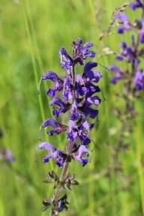  Link to map | Maintain low soil nutrient levels, prevent scrub encroachment, and graze at key times to reduce coarse, dominant grasses in suitable sites where Meadow Clary is present or has been present.  The removal of sward by hay cutting or grazing after plants have flowered and set seed is advised, in addition to maintaining a degree of disturbance to provide bare patches of soil for seedling recruitment.  It would be important to maintain or introduce careful grazing regimes on grasslands and meadows where this species has been present, practice low-input sustainable farming methods to enhance and achieve greater areas of unimproved grassland.  Meadow Clary declined rapidly when agricultural practices began to increase the fertility of grassland by ploughing, applying fertiliser, and re-seeding with ‘more productive’ grassland species.  Now this plant is very restricted in its national range, down to about 20-30 known sites in the UK (mostly in the Cotswolds) of which about half are reported to be in Oxfordshire. As such, Oxfordshire has a particularly important role for the national recovery of this species. Do consider the climate predictions for Meadow Clary’s range over time by the Met Office. | Cotswolds sites where the species is, or has been  present. | Meadow Clary (Salvia pratensis)

Military Orchid  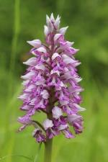  Link to map | Manage woodlands for Military Orchids and create open conditions in glades. Exclude and control deer and rabbits and clear moss cover as necessary around the orchids.  Open conditions can be achieved through selective felling to expand glades, controlled time-limited grazing, seasonal mowing, or raking vegetation to control encroaching scrub near existing orchid populations. Oxfordshire has 6 records of Military Orchids in the past 30 years.  This orchid takes four years to grow from seed but can live for 15 years. Because they take such a long time to grow, management of sites where they already exist is of key importance to their survival in Oxfordshire. | Woodlands south of Lower Assendon and south of Christmas Common | Military orchid (Orchis militaris) | 
Monkey Orchid  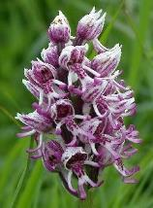  Link to map | Manage chalk grassland to retain moisture and increase populations of the Monkey Orchid. Identify suitable sites (without Lady Orchids) to reintroduce and manage Monkey Orchids to expand their range and prevent  extinction.  There are three known populations of Monkey Orchid in the UK and Oxfordshire has one of these remaining populations present at  Hartslock nature reserve. Here the chalk grassland supports a range of rare species including one of the UK’s three populations of Monkey Orchid. This orchid typically flowers earlier than others (around May) and care should be taken to manage the area according to its flowering period. A potential major risk to the Hartslock population is their hybridisation with Lady Orchids which are present at the same site. Targeted reintroduction of Monkey orchids to suitable sites where Lady Orchids are absent offers a way to secure the future for this species. | Hartslock nature reserve | Monkey Orchid (Orchis simia)

Reptiles

Species by  Common Name (ordered A – Z) | Potential measure (the action needed to help the relevant species to recover). Potential measures are in bold with additional detail about the species added below. | Particularly important locations  for the action(s) | Which species are intended to benefit  most? | Habitat
Adder  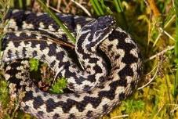  Link to map | Create new Adder habitats with mosaic areas of heathland, scrub, grassland, and woodland. Or manage and enhance existing mosaics to reintroduce adders.  Find detailed advice about managing habitat for adders here. Create or manage habitats that have a diverse vegetation structure (a mixture of different heights) with open, sunny areas for basking. Rides and glades at woodland edges can be important and the ground topography should be varied to create features for basking, shelter, and safe hibernation. Limit disturbance within these mosaic habitats and follow advice about game bird releases and management to limit impacts on flora and fauna.  Adders used to be widespread in Oxfordshire before the year 2000 but recent evidence shows strong declines across northern Europe.  Oxfordshire itself may have one remaining population of adders which were previously reintroduced back into the county. Small and fragmented populations are highly vulnerable to extinction.  Major threats to adders include predation by game birds, disturbance and persecution by people. There is potential for expanding existing habitats where adders remain, and for carefully targeted re- introduction of adders into suitable locations following IUCN guidelines and working with authorities and local reptile organisations across  borders to restore habitat connectivity with populations in neighbouring counties. | The final Oxfordshire adder  population in the Chilterns. Most likely to be suitable in the Chilterns or  Cotswolds. | Adder (Vipera berus)

Common lizard  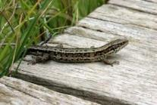  Link to map | Carefully manage habitat near known lizard colonies to create open, sunny places in dry, exposed sites with areas of dense cover nearby where they can feed on spiders and insects.  Common lizards have been widespread across Oxfordshire but their current numbers and range are not as well-known besides some  protected sites like Otmoor and Wychwood.  Where they are known to be present, and where habitat management is appropriate, they are doing well. The greatest threats to their success include the fragmentation and disturbance of their habitats and predation by birds.  If common lizards are lost from a site, there is little to no opportunity that they will naturally recolonise the location so additional survey and monitoring work is also needed to understand where populations are present locally. | Otmoor, Wychwood, Banbury County Park | Common lizard (Zootoca vivipara)

You have now reached the end of Oxfordshire’s LNRS Species Priorities List. Please report any sightings of these (and other) species to TVERC to help inform future biodiversity recovery work.

Summary
The list above contains 63 specific actions which support 61 key species e.g. ‘Monkey orchid’ (or groups of species e.g. ‘Bats’).

Whilst those actions are targeted towards 61 key species and species-groups, the actions are expected to benefit a total of 105 species which are considered to be threatened or near threatened with extinction. You can find each and all of these 105 species listed in the right-hand column of the above table. In addition, these species-specific actions would also have knock-on wider benefits to a further, non-exhaustive list of species which cannot all be mentioned here. The column of ‘particularly important locations’ were noted to add context for readers but those locations should not limit people from taking actions in other place.

How will other threatened and near-threatened species be supported in the LNRS?
There are approximately 800 other threatened and near threatened species in Oxfordshire in addition to the listed above. You can view the full list of over 800 species on the Local Nature Recovery Strategy webpage. Whilst those additional 800 species are also important species to recover, it is expected that they will benefit through the large-scale habitat improvement(s) which are listed on the LNRS’s Statement of Biodiversity. These actions involve enhancing existing habitats, improving landscape-scale connectivity between habitats, and the creation of new habitats to help the population numbers of many of those species to recover and spread. In some cases, some of the other 800 species require more evidence to better understand what actions they need to help them recover.

Acknowledgements

The LNRS would like to acknowledge the support given by the LNRS partners as well as species experts and county recorders (nationally and locally) who have helped to create this Species Priorities List. Collecting the specific actions needed by nearly 900 threatened and near-threatened species is a significant undertaking and we have only been able to create this with the support from individuals and organisations who have collaborated with this project.

During the longlisting and shortlisting processes, Oxfordshire received support for the LNRS partner organisations (see logos below) as well as contact with over 70 species experts. Alongside the LNRS partner organisations we also heard responses from species representatives from:

- Banbury Ornithological Society





















- Banbury Town Council
- Butterfly Conservation Upper Thames Group
- Centre for Hydrology and Ecology
- Environment Agency
- Forestry Commission
- Natural England
- Oxfordshire Amphibian and Reptile Group
- Oxfordshire Bat Group
- Oxfordshire Ornithological Society (OOS)
- Plant Life
- RSPB Otmoor
- Species Recovery Trust
- The Ashmolean Natural History Society of Oxfordshire (ANHSO)
- The Fungus Survey of Oxfordshire
- The River Thame Conservation Trust
- Over 20 further county recorders and individuals with expertise in habitat management for a variety of species.
- Representatives from each of the LNRS project partner organisations (see image)

Images and credits
The images used within this document are not those owned by Oxfordshire County Council and were made available by the following for the purposes of illustration, their inclusion does not indicate that the photographers endorse this strategy.

- Adder: Adder | Adder Vipera berus Credit: © Natural England/Allan D… | Flickr
- Barberry Carpet Moth: Barberry Carpet Moth | Barberry Carpet Moth (Pareulype berbe… | Flickr
- Bats: Myotis bechsteinii | Netopier Bechsteinov Bechstein's Bat | Ján Svetlík | Flickr
- Bats (woodland specialists): Myotis bechsteinii | Gilles San Martin | Flickr
- Beaver: (explored) Beaver in the neighbourhood, Almere, May 2021 | Flickr
- Beetle of Autumn Gentian: Smicronyx reichi | Mark Gurney | Flickr
- Bittern: Bittern | Richard Towell | Flickr
- Black Poplar trees: Black Poplar Trees - Worcestershire | Pool / Berrow Down / C… | Flickr and true fly: Wood soldier fly (Solva marginata, Xylomyidae), Parc de Wo… | Flickr
- Blackthorn butterflies: Black Hairstreak - butterfly | Black Hairstreak, Glapthorn C… | Flickr
- Breeding waders: Common snipe 2016-08-05_07 | Thomas Landgren | Flickr
- Common lizard: Common Lizard | Common Lizard (Zootoca vivipara) © Natural E… | Flickr
- Cigarello Gall-Fly: no image
- Clubbed general soldierfly: Stratiomys chamaeleon (Diptera: Stratiomyidae), ♀ | Stratiom… | Flickr
- Creeping Marshwort: photo provided, courtesy of Judy Webb
- Curlew: Curlew | Scotland | caroline legg | Flickr
- Dark Green Fritillary: Speyeria aglaja | dark green fritillary Großer Perlmuttfalte… | xulescu_g | Flickr
- Desmoulin’s Whorl Snail: Vertigo moulinsiana | This very small snail (3-4mm) is one o… | Flickr
- Devil’s-bit Scabious Devil's-bit Scabious (Succisa pratensis) Dipsacaceae | Flickr and Marsh Fritillary: Marsh Fritillary | Etienne Gosse | Flickr
- Downy Woundwort: Stachys germanica, Saltway | Sam Thomas | Flickr
- Duke of Burgundy Butterfly: Hamearis lucina | Duke of Burgundy Schlüsselblumen-Würfelfal… | xulescu_g | Flickr
- Dung specialists and dung beetles: Asilus crabroniformis | Hornet Robberfly female Finistère, F… | Flickr
- Ellipteroides alboscutellatus: no image
- Farmland Birds: Alvéola-amarela, Yellow Wagtail | Motacilla flava, Leziria g… | Flickr
- Fen violet: Fen violet | Fen violet Viola stagnina Cambridgeshire Copyri… | Flickr
- Fish: Brown Trout at Seedskadee National Wildlife Refuge | Flickr and European Eel (Anguilla anguilla) | Aquarium du Val-de-Loire,… | Flickr
- Fungi and fungi-associated plants found with woodland: Yellow Bird's-nest, Hypopitis monotropa, Brierley Wood SK3… | Flickr and Satan's Bolete, Devil's Bolete (Rubroboletus satanus) (Bol… | Flickr
- Great Crested Newt: Great-crested newt | Streatham Common, The Rookery | Carron Brown | Flickr
- Greater Water-Parsnip: Greater Water-parsnip | At Upton Marshes Nature Reserve, Nor… | Flickr
- Hazel dormouse: Hazel dormouse (Muscardinus avellanarius), Skole, Lviv Obl… | Flickr
- Hedgehog: Twinklehog comes to say hi | Beautiful mature Hedgehog trund… | Flickr

- Juniper: Juniperus communis | Juniperus communis | Joan Simon | Flickr
- Lichens (on veteran trees): Usnea articulata on dead hawthorn twigs | Usnea articulata (… | Flickr
- Limestone fern: Gymnocarpium robertianum, Nr. Killour, Mayo | Sam Thomas | Flickr
- Liquorice Piercer Moth: Grapholita pallifrontana | Exemplar found: Russia, Moscow Ob… | Flickr
- Long-Leaved Helleborine: Miekkavalkku, narrow-leaved helleborine (Cephalanthera lon… | Flickr
- Lousewort flea beetle: no image
- Meadow Ant Hoverfly: Microdon devius, North Wales, June 2016 | Janet Graham | Flickr
- Meadow Clary: Meadow sage - Salvia pratensis | Björn S... | Flickr
- Military Orchid: Military orchid - Orchis militaris | Björn S... | Flickr
- Monkey Orchid: Monkey Orchid Orchis simia | Parkgate Kent | Len Worthington | Flickr
- Montagu’s Harrier (cropped image): A Montagu's Harrier in flight | A migratory raptor from Cent… | Flickr
- Moths of Dyer’s Greenweed: no image
- Mountain Bulin snail (cropped image and rotated): Ena montana | gastropods.wordpress.com/2017/07/07/photo-of-t… | Flickr
- Nightingale: Nightingale | Mathijs van Lisdonk Photography | Flickr
- Noble chafer: Noble Chafer - Gnorimus nobilis on Meadowsweet | WWT Grafton… | Flickr
- Otter: old world otter eating a fish | A picture of an otter | Flickr
- Silver Spotted Skipper: silver spotted skipper - Hesperia comma | Thanks to Hippobos… | Flickr
- Small Blue butterfly - Small Blue | Cupido minimus - Pitstone, Buckinghamshire, UK,… | Flickr
- Snail killing fly: Sciomyza dryomyzina male - Brook Meadow, Warwickshire 2009… | Flickr
- Southern Damselfly: Southern Damselfy at rest | At a location in the New Forest | Flickr
- Spider (Tuberta maerens): no image
- Stone Curlew: Alcaravão | Alcaravão Burhinus oedicnemus Eurasian Thick-kne… | Flickr
- Striped Lychnis Moth: Striped lychnis caterpillar 2a - Shargacucullia lychnitis | Flickr
- Swifts and House martins: Gierzwaluw - Apus apus | Gierzwaluw - Apus apus | Flickr and House Martin | An archive shot from the Romney Marsh, during… | Flickr and Tornseglare i holk | Fem dagar efter uppsättning sitter en t… | Flickr and House Martin (Delichon urbicum) | The photos contained in th… | Flickr
- Turtle Dove: Turtle Dove ( Streptopelia turtur ) ... Sutton Bank , York… | Flickr
- Water Vole: Water Vole | Seen at the British Wildlife Centre, Newchapel,… | Flickr
- White Admiral: Väikelumik; Limenitis camilla; White Admiral | Tirbiku, Lään… | Flickr
- White Clawed Crayfish: White-footed Crayfish (Austropotamobius pallipes) | Aquarium… | Flickr
- White letter hairstreak: White-Letter Hairstreak | At Brockholes | HELEN M BUSHE | Flickr
- Willow Tit: Willow Tit | Willow Tit - Parus montanus - Пухляк Russia, Mo… | Flickr
- Wood White butterfly: Leptidea sinapis-reali 170717 116.jpg | Jürgen Mangelsdorf | Flickr

Appendix A
This list shows all the species from Oxfordshire’s LNRS Species Priorities List in alphabetical order by their common or group name

  - Adder
  - Barberry Carpet Moth
  - Bats
  - Beaver
  - Beetle of Autumn Gentian
  - Bittern (and Marsh Harrier)
  - Black Poplar trees
  - Blackthorn butterflies
  - Breeding waders
  - Cigarello Gall-Fly
  - Clubbed general soldierfly
  - Common lizard
  - Creeping Marshwort
  - Curlew
  - Dark Green Fritillary
  - Desmoulin’s Whorl Snail
  - Devil’s bit scabious (and Marsh fritillary)
  - Downy Woundwort
  - Duke of Burgundy Butterfly
  - Dung specialists and dung beetles
  - Ellipteroides alboscutellatus
  - Farmland Birds
  - Fen violet
  - Fish
  - Fungi and fungi-associated plants found with woodland
  - Great Crested Newt
  - Greater Water-Parsnip
  - Hazel dormouse
  - Hedgehog
  - Juniper
  - Lichens (on veteran trees)
  - Limestone fern
  - Liquorice Piercer Moth
  - Lousewort flea beetle
  - Long-Leaved Helleborine
  - Meadow Ant Hoverfly
  - Meadow Clary
  - Military Orchid
  - Monkey Orchid
  - Montagu’s Harrier
  - Moths of Dyer’s Greenweed
  - Mountain Bulin snail
  - Nightingale
  - Noble chafer
  - Otter
  - Silver Spotted Skipper
  - Small Blue butterfly
  - Snail killing fly
  - Southern Damselfly
  - Spider (Tuberta maerens)
  - Stone Curlew
  - Striped Lychnis Moth
  - Swifts and House martins
  - Tawny Owl
  - Turtle Dove
  - Water Vole
  - White Admiral
  - White Clawed Crayfish
  - White Letter Hairstreak
  - Willow Tit
  - Wood White butterfly

Appendix B
The full set of distribution maps for each and all the species on this Species Priority List. On the following pages you can see the maps that are linked to from the list of species above. The maps indicate where each species or group of species has previously been recorded in the county. It does not mean that actions to support species has to be taken only in those locations. Instead the purpose of these maps is to enable people to get a sense of whether the action is likely to be relevant in their area of the county. If these species are found in other areas of the county in future, the LNRS supports you to take the relevant species-specific actions in those locations too.

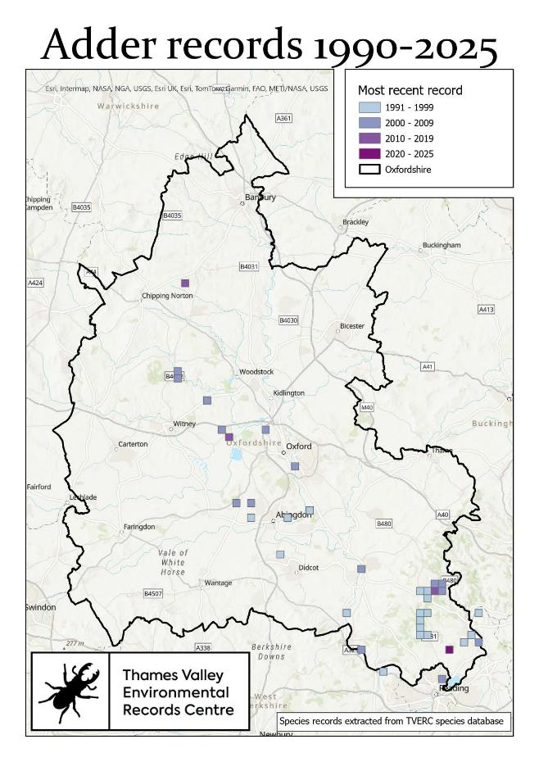
Return to list
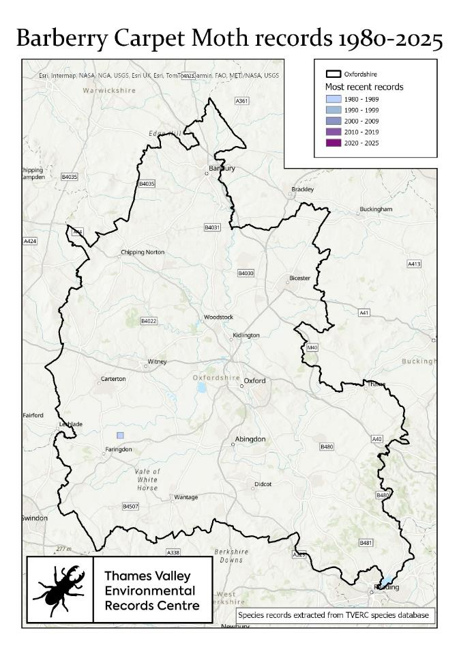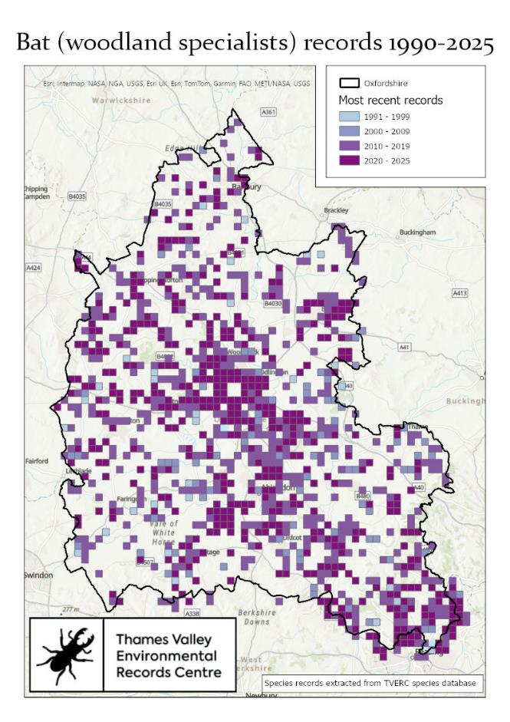
Return to list Return to list

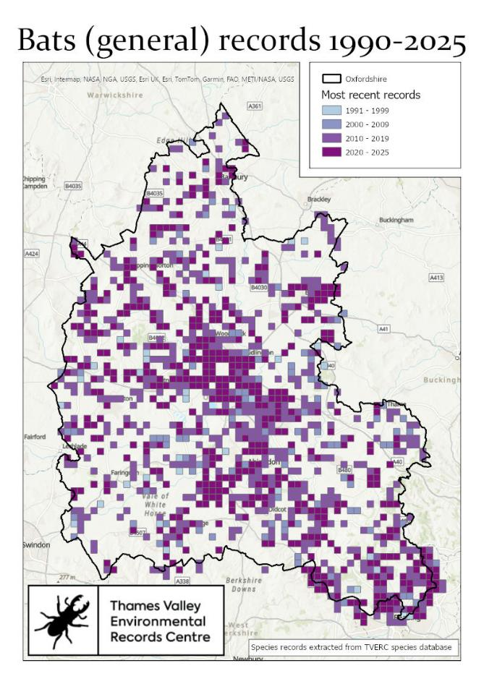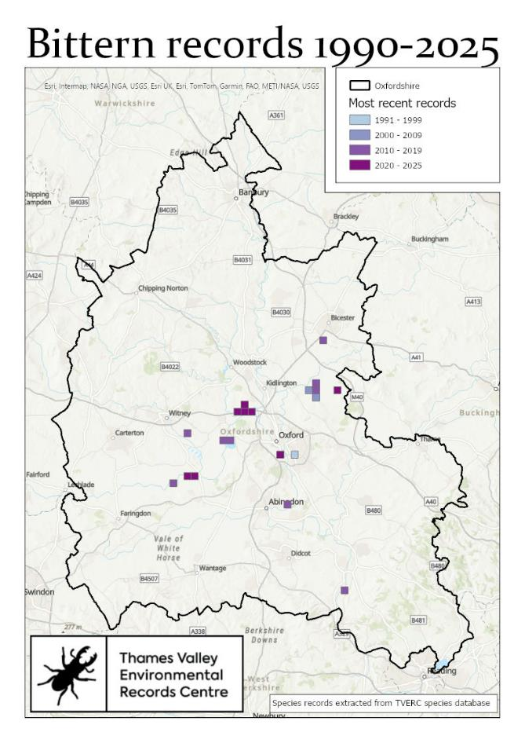
Return to list Return to list
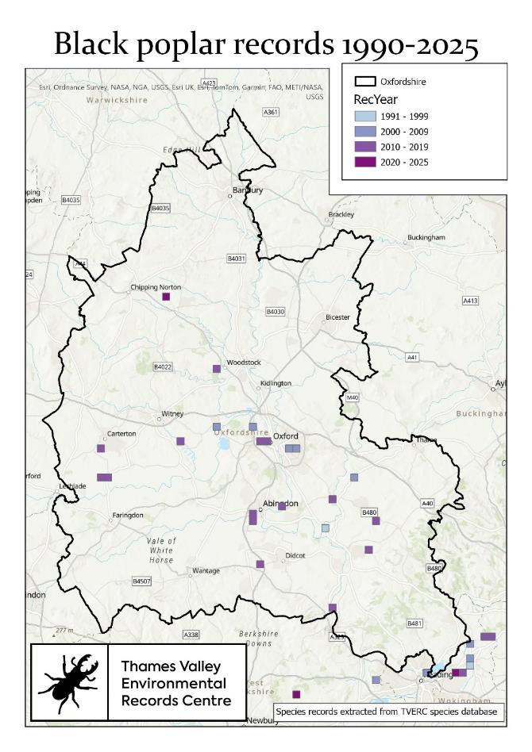
Return to list
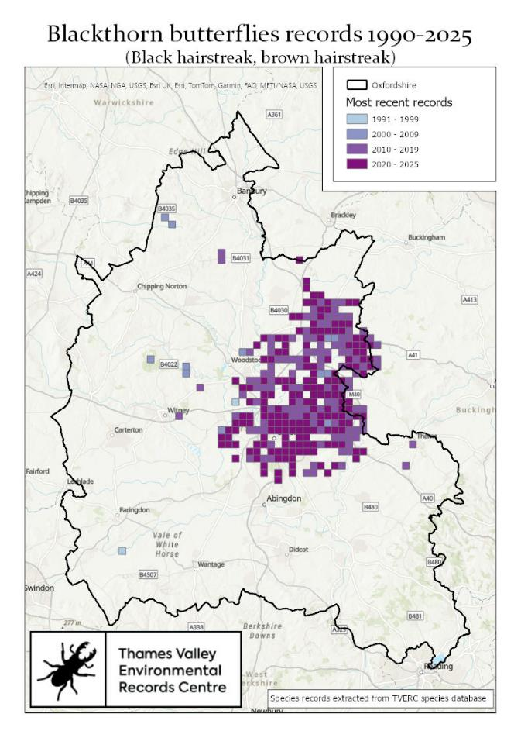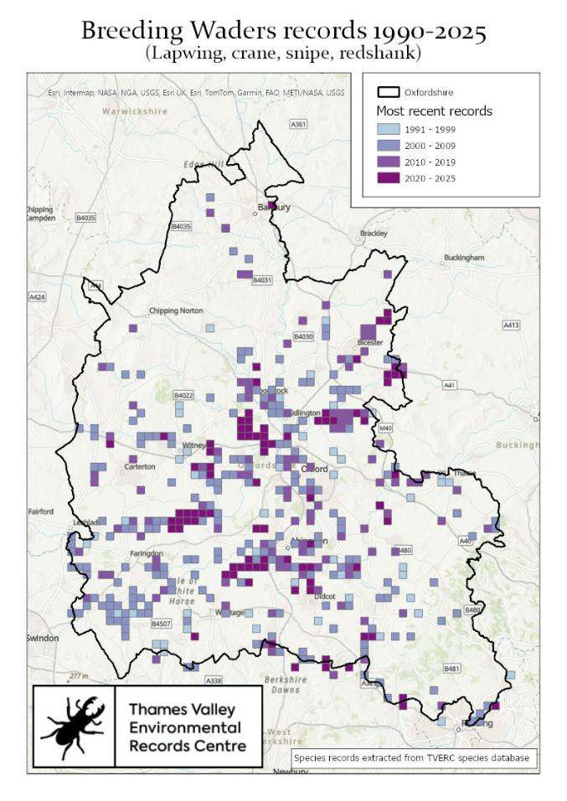
Return to list Return to list

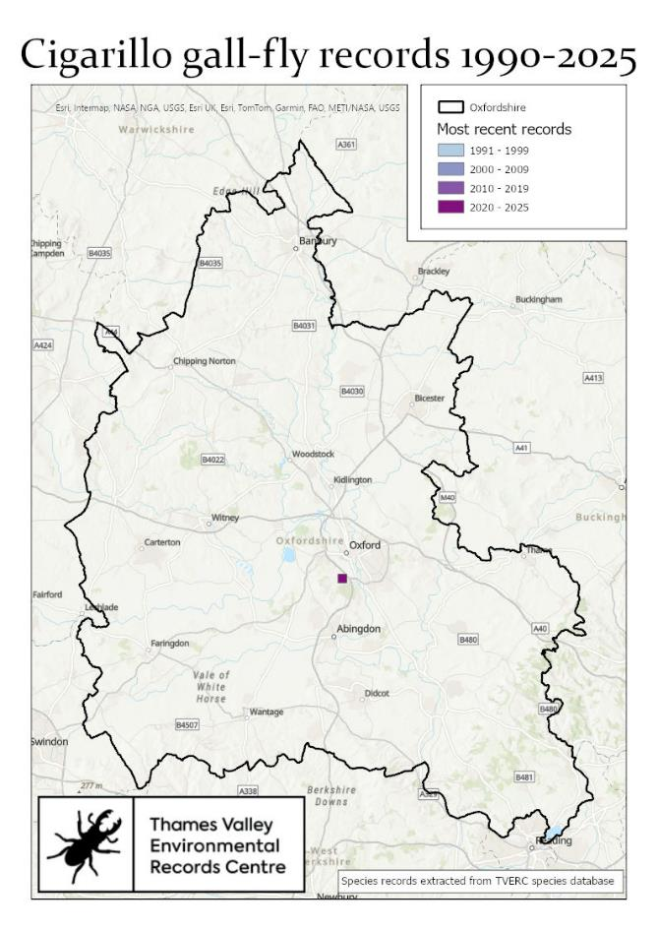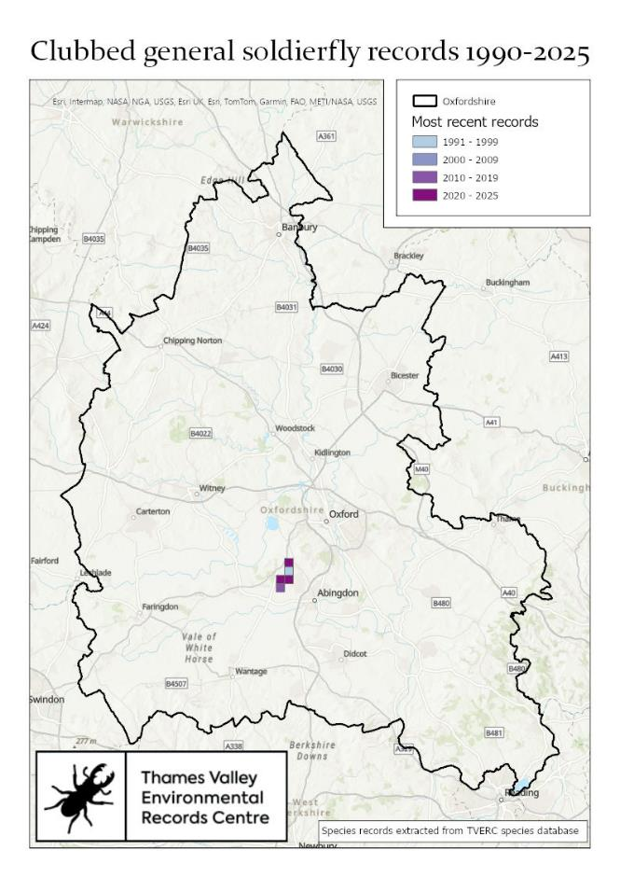
Return to list Return to list

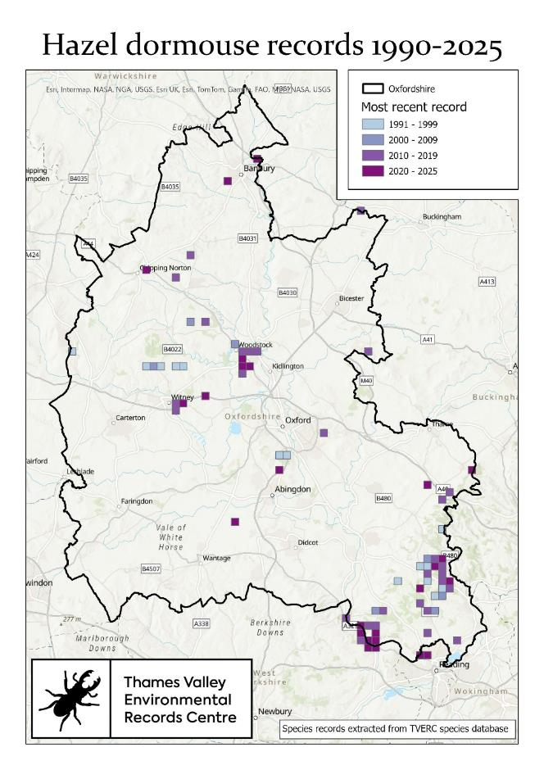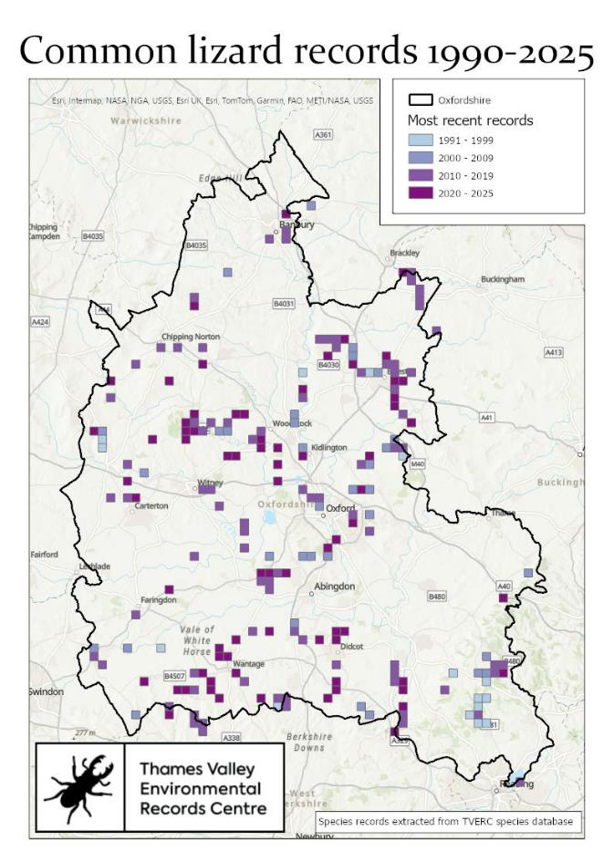
Return to list Return to list

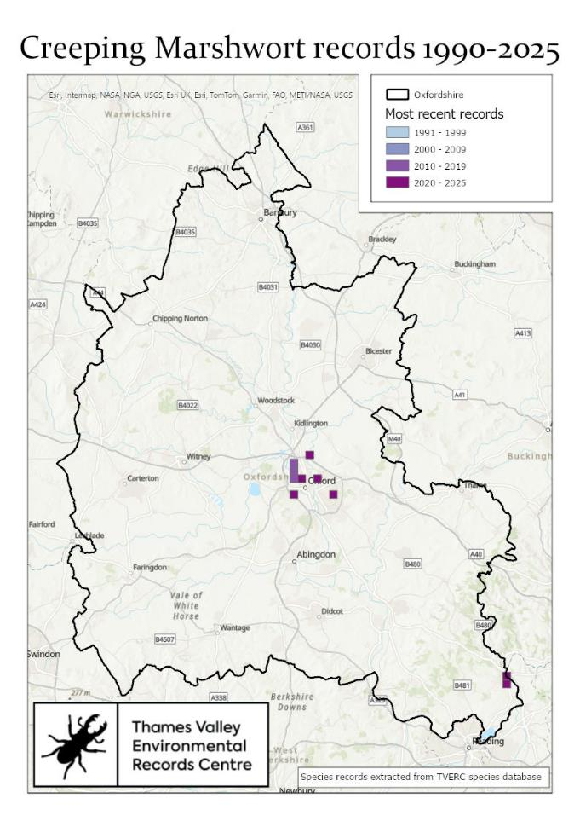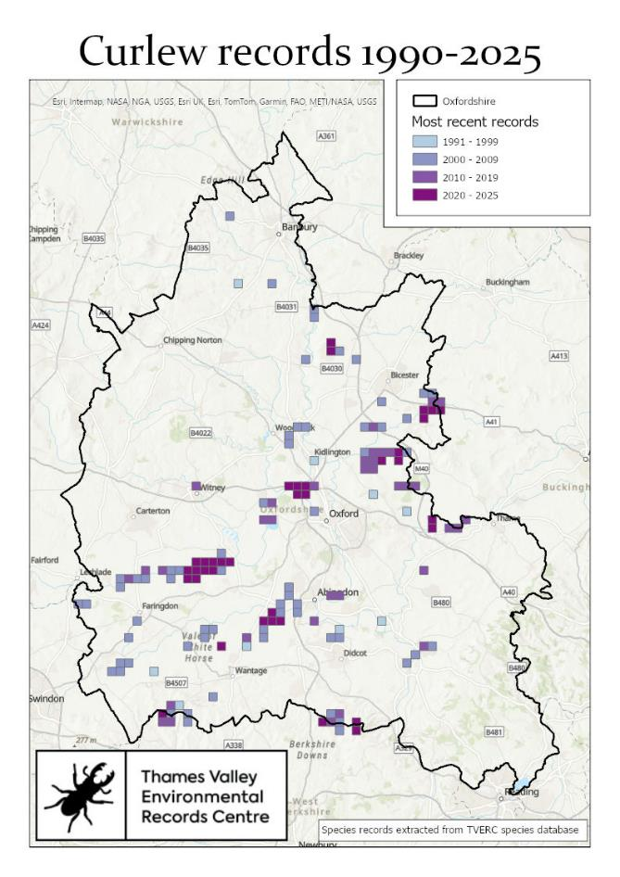
Return to list Return to list
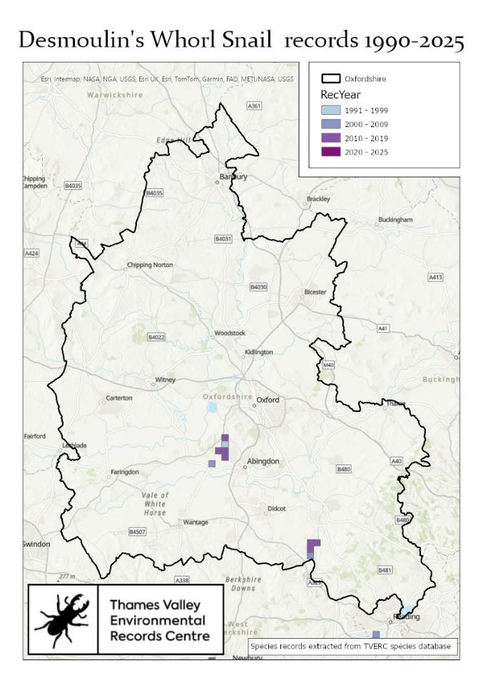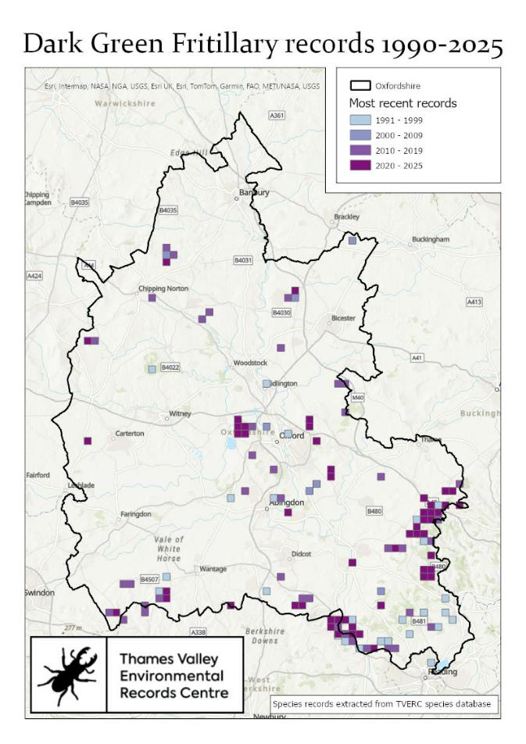
Return to list Return to list
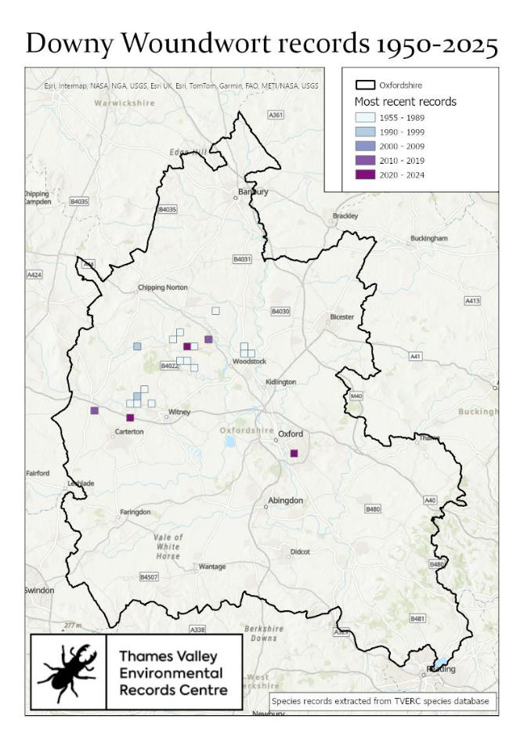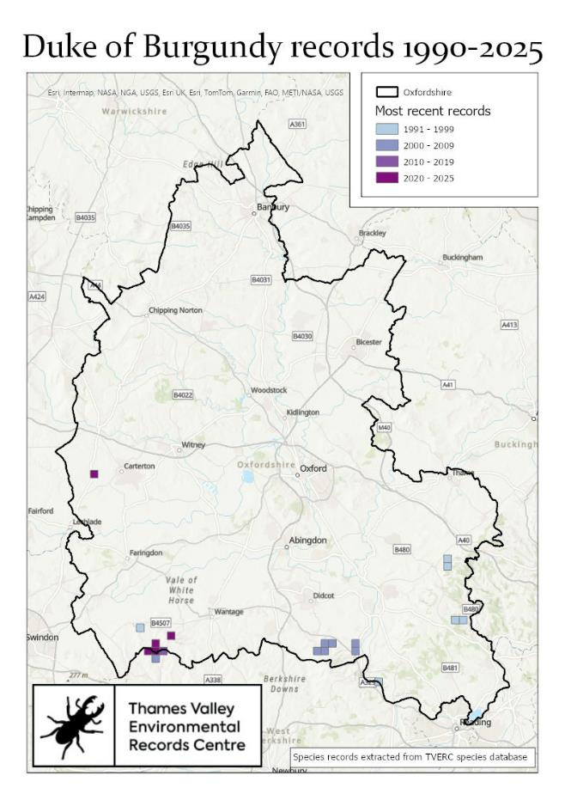
Return to list Return to list

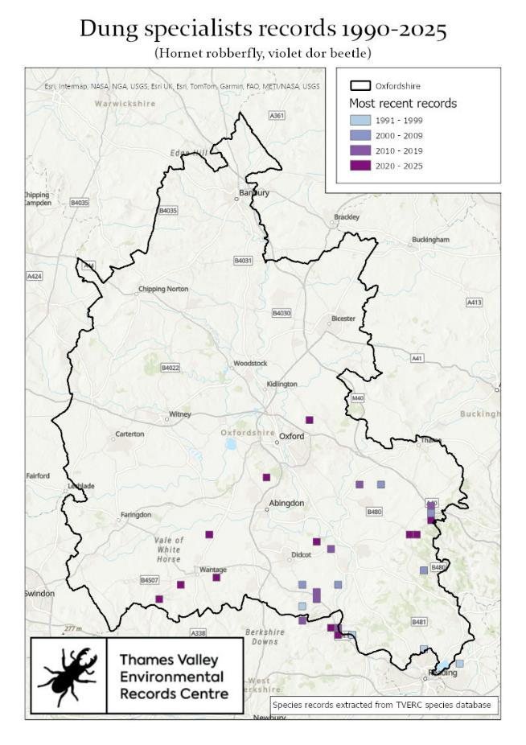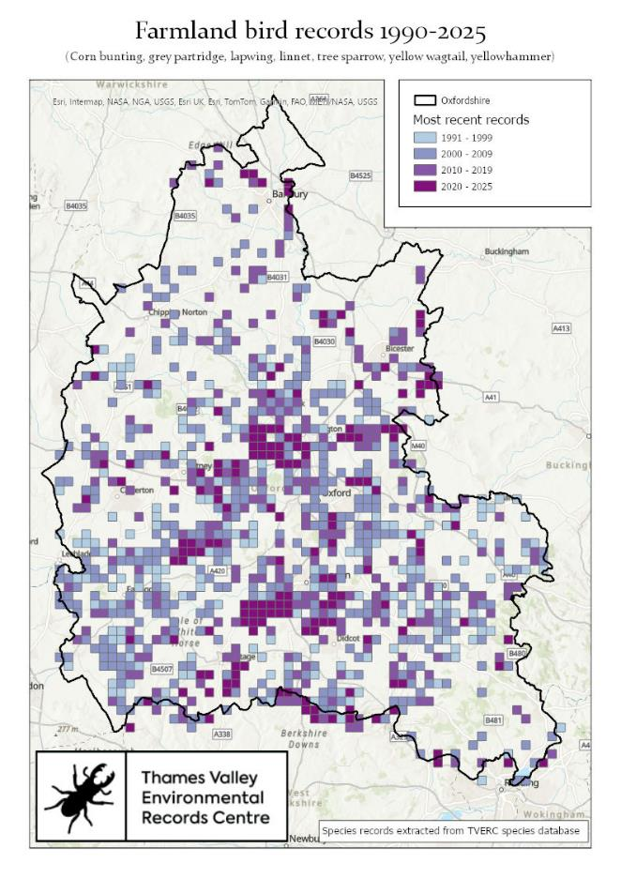
Return to list Return to list

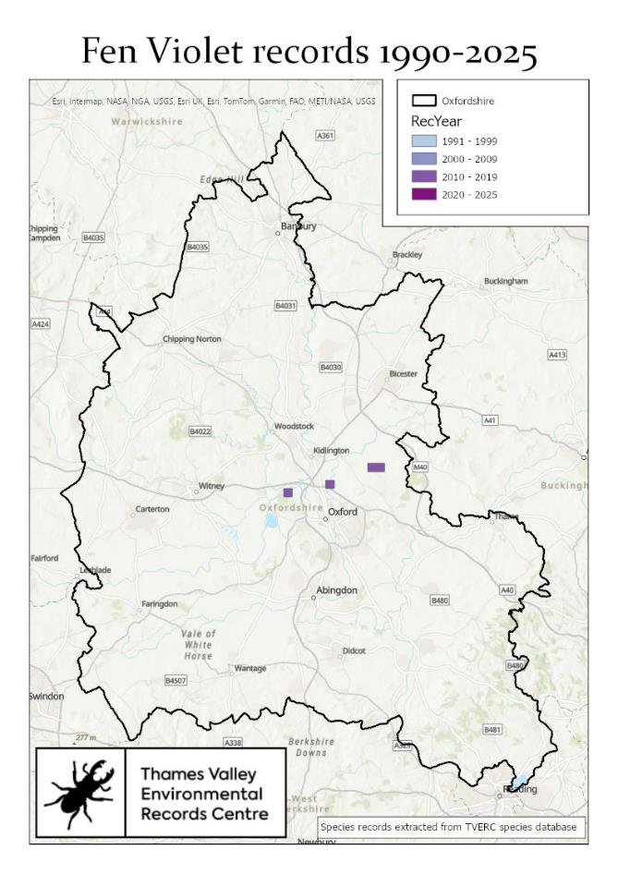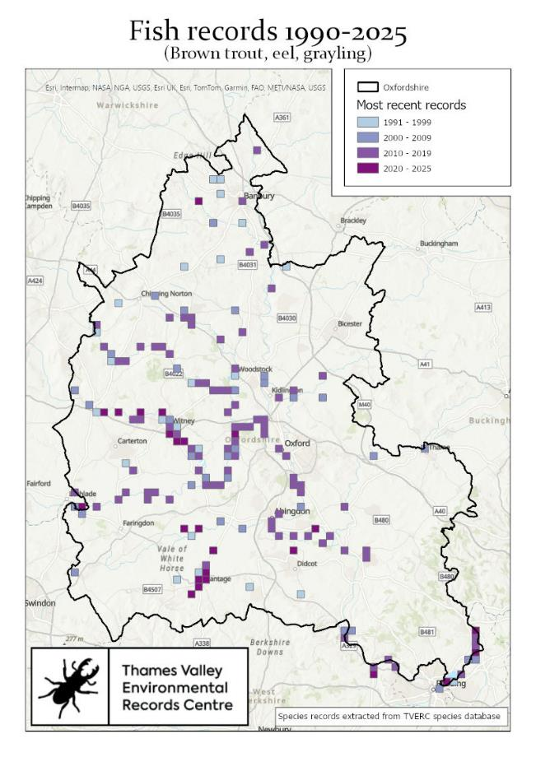
Return to list Return to list

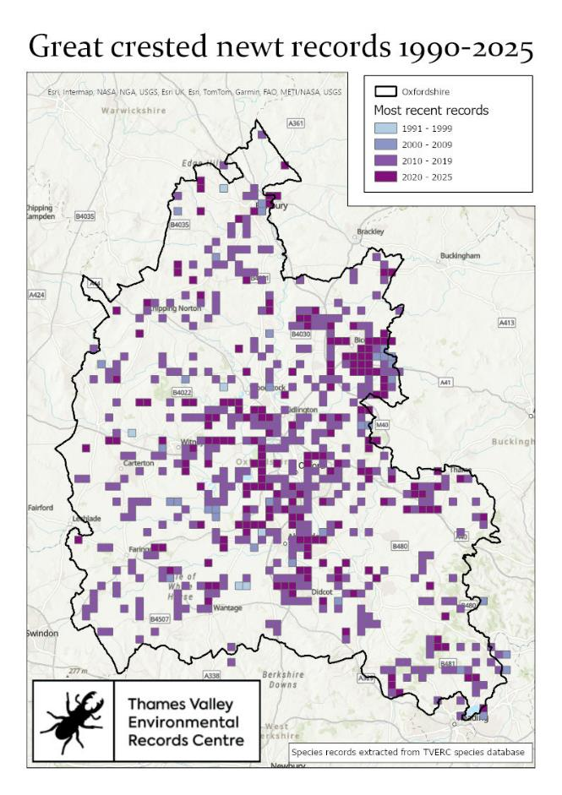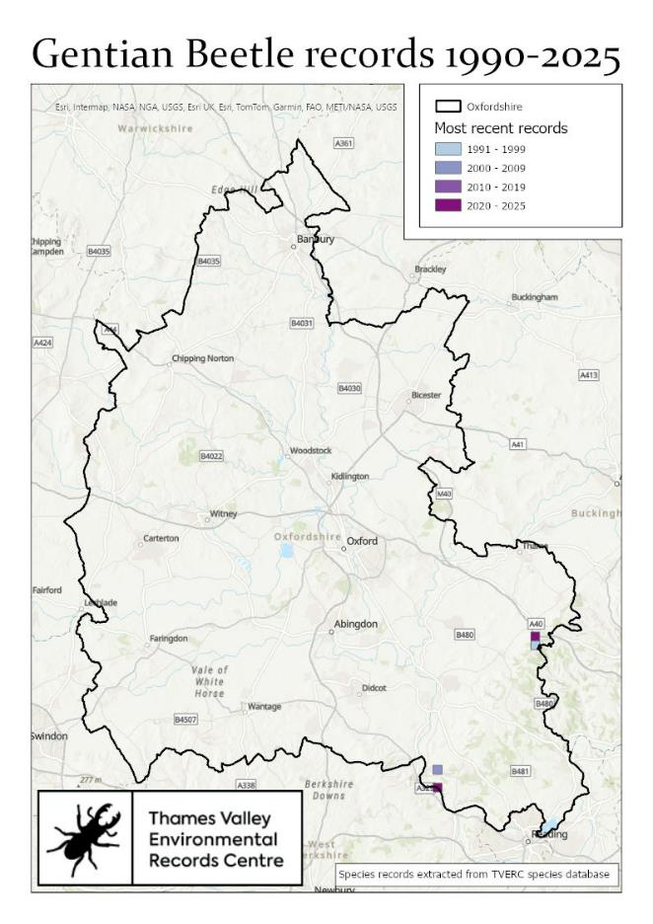
Return to list Return to list

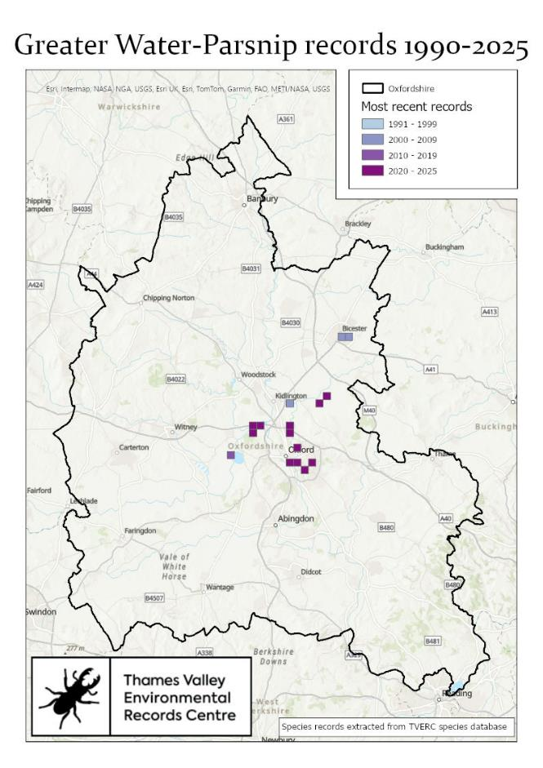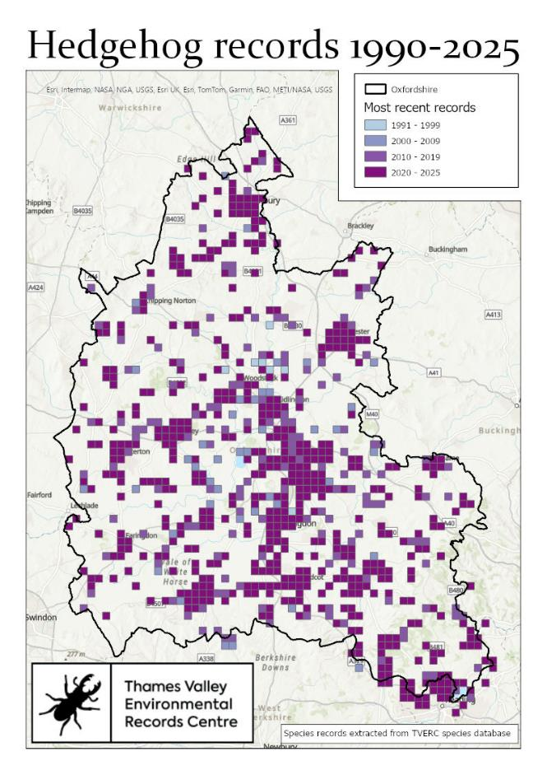
Return to list Return to list

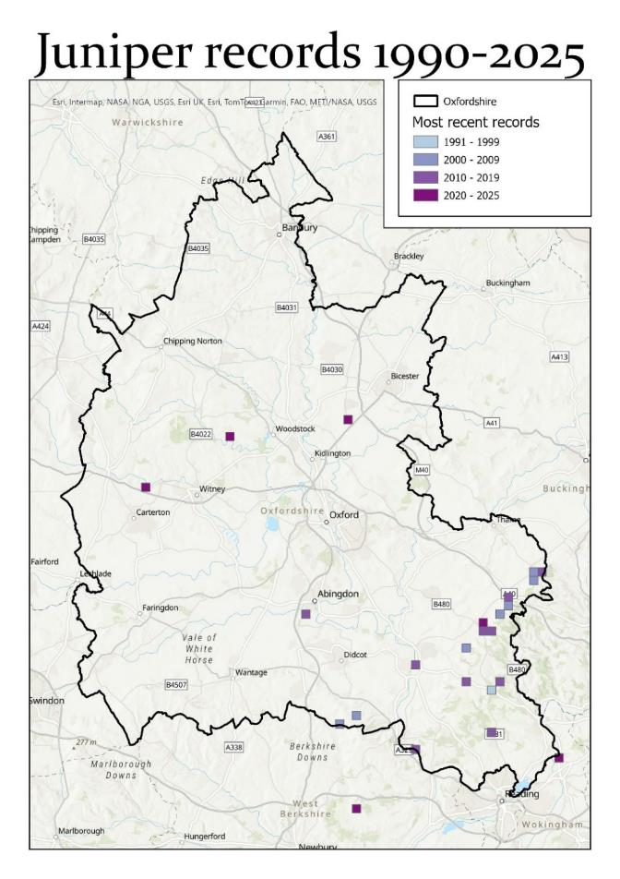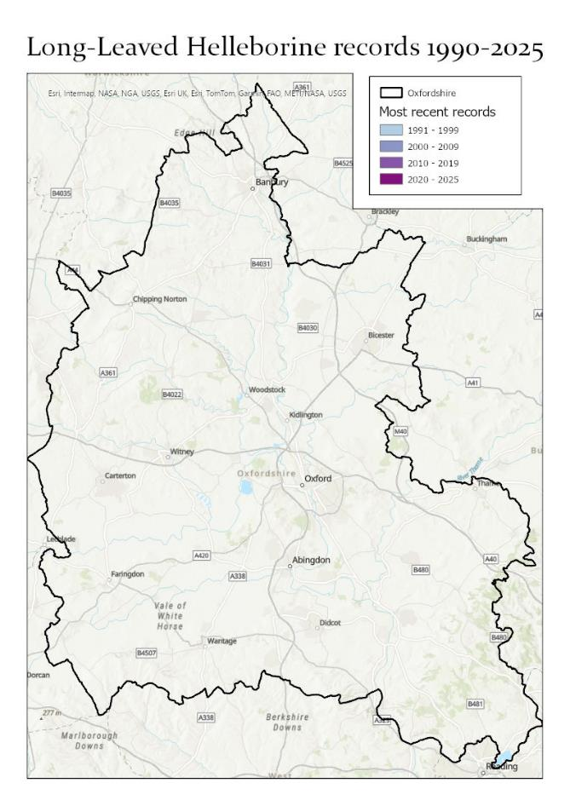
Return to list Return to list No recent records
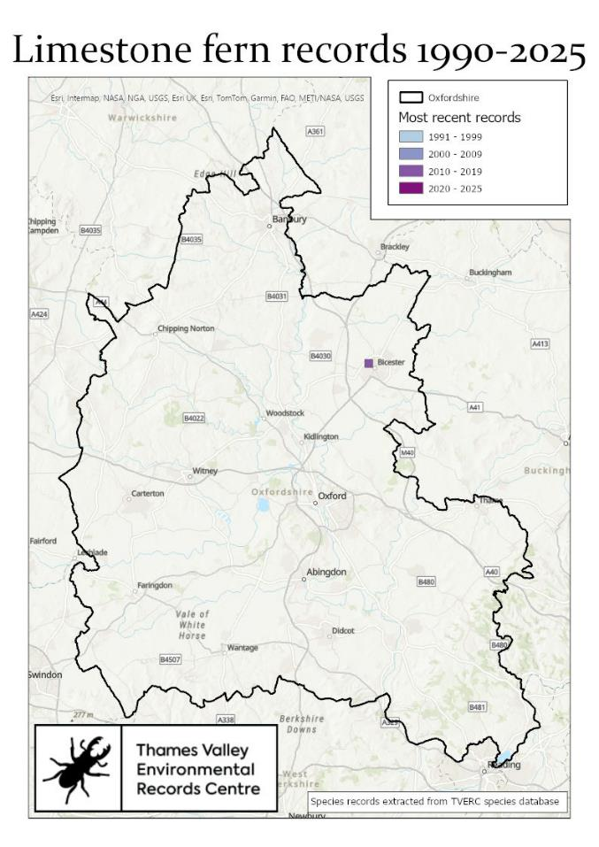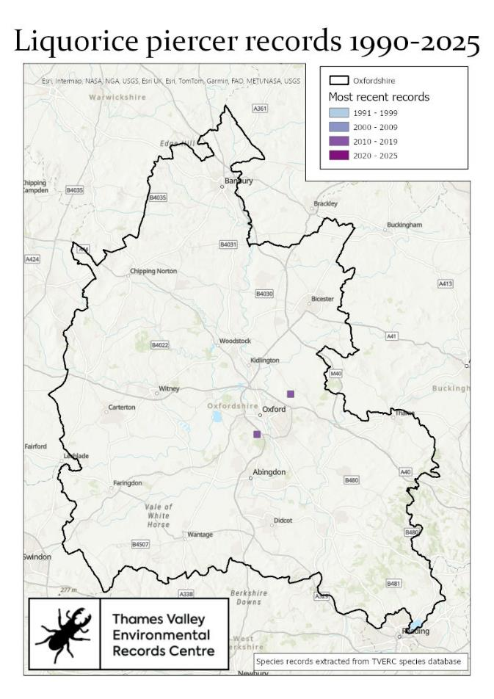
Return to list Return to list
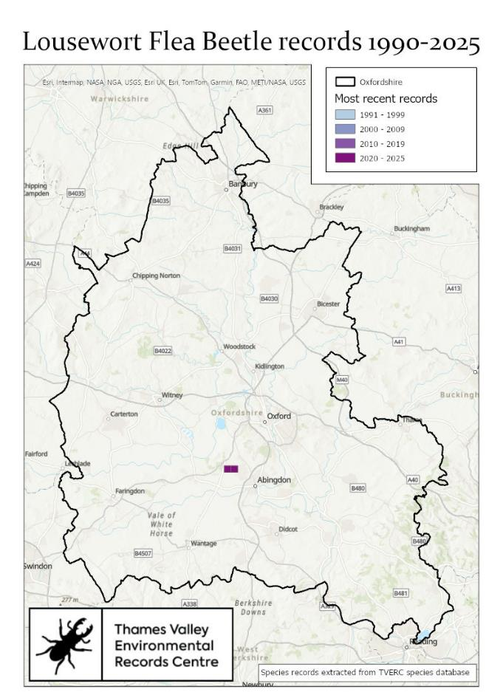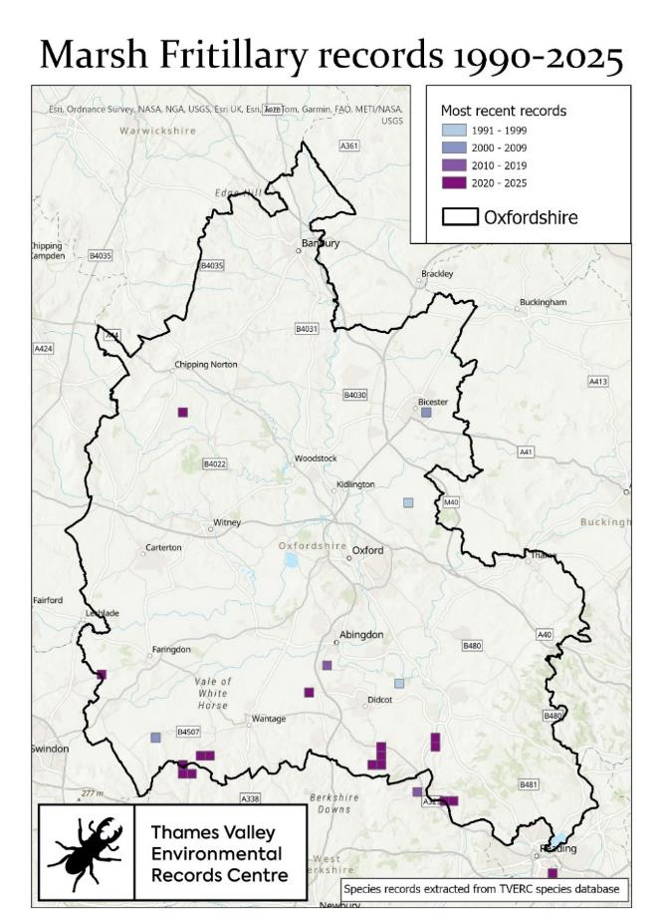
Return to list Return to list

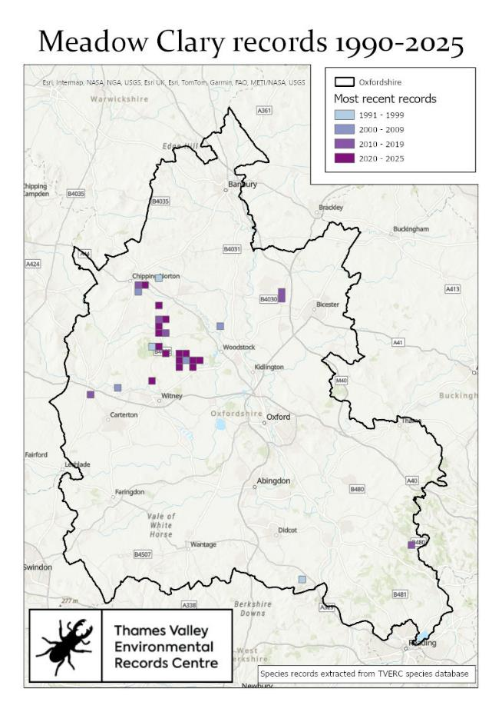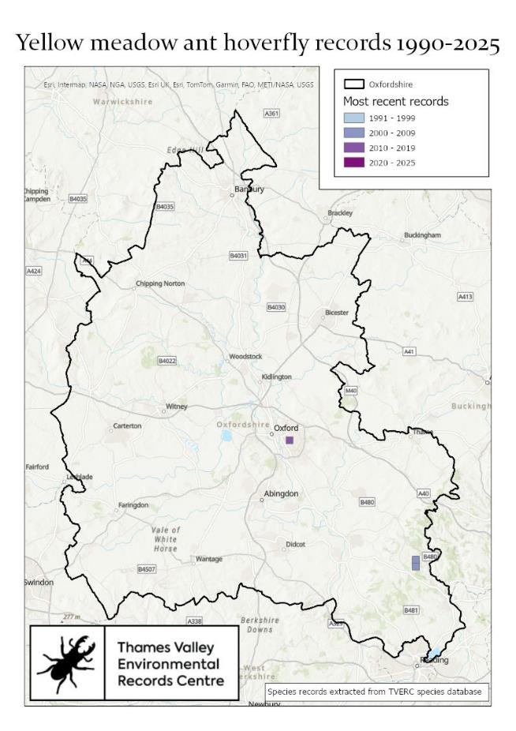
Return to list Return to list

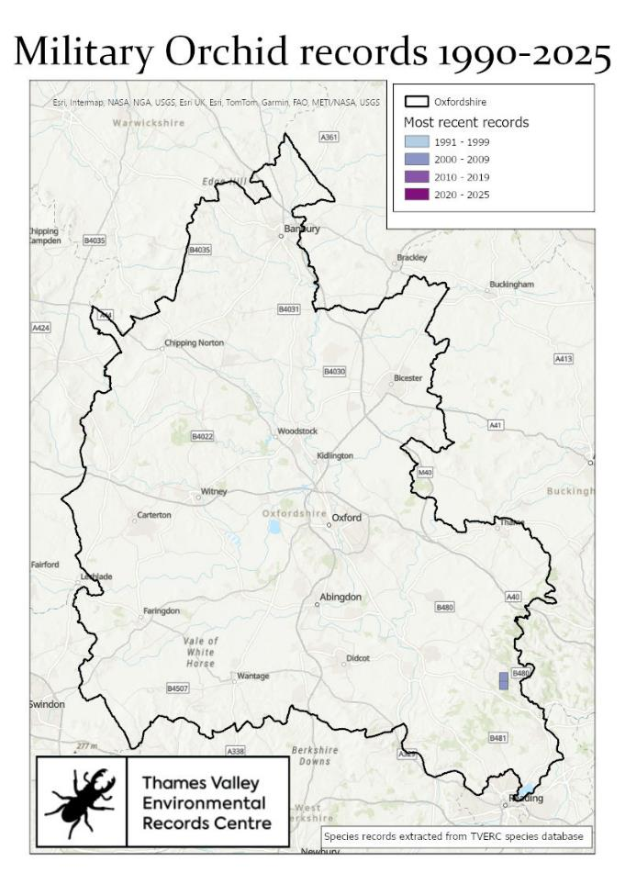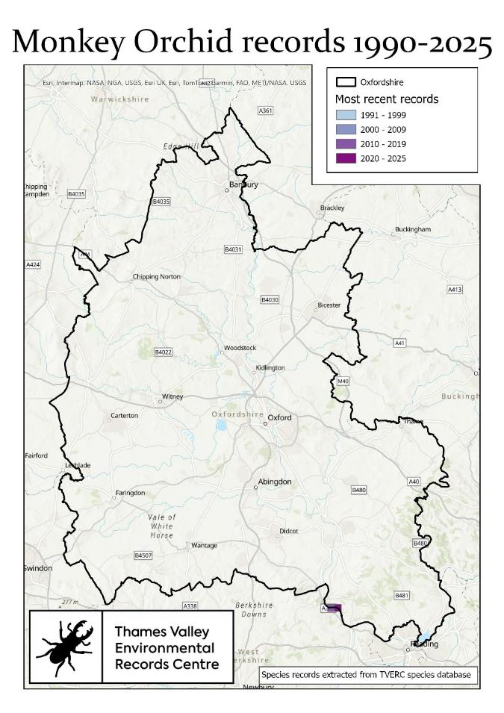
Return to list Return to list

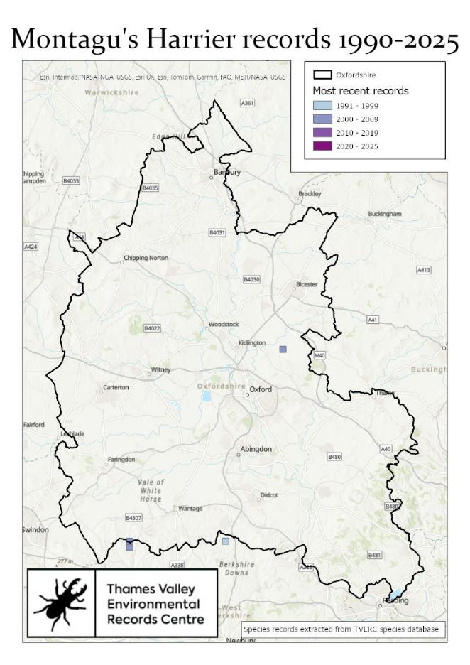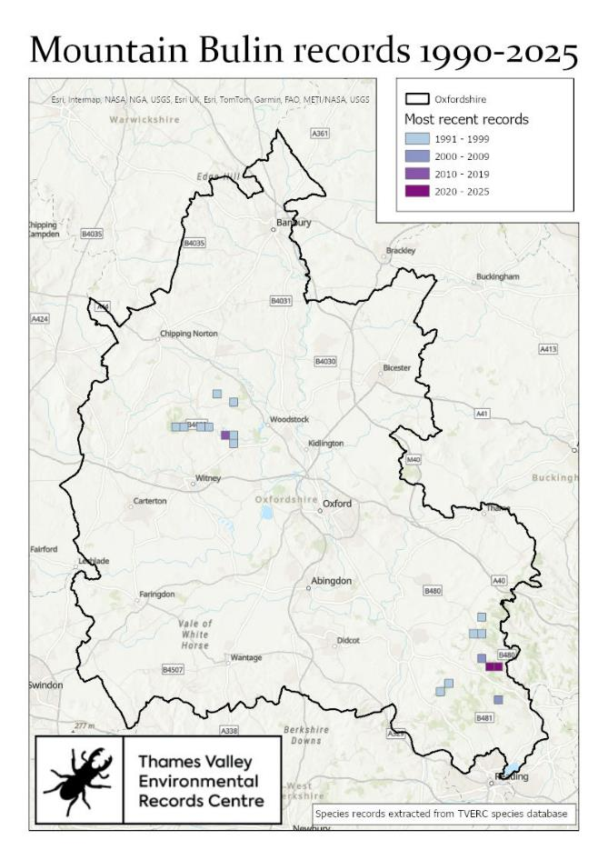
Return to list Return to list
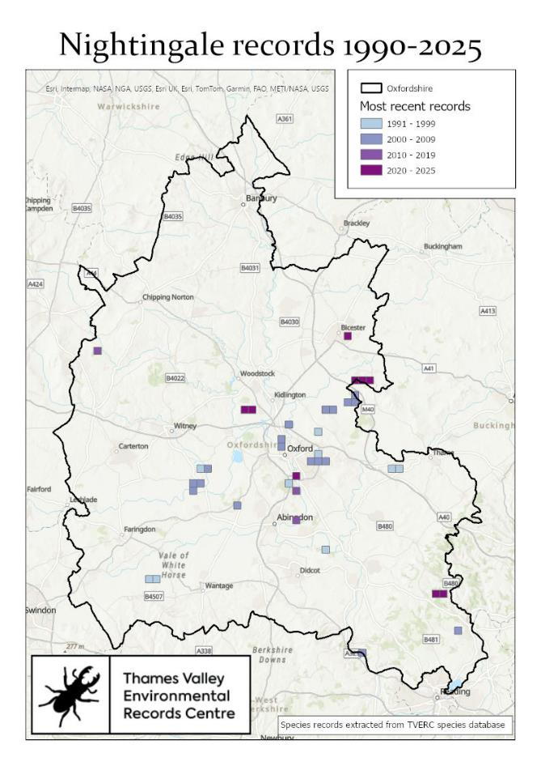 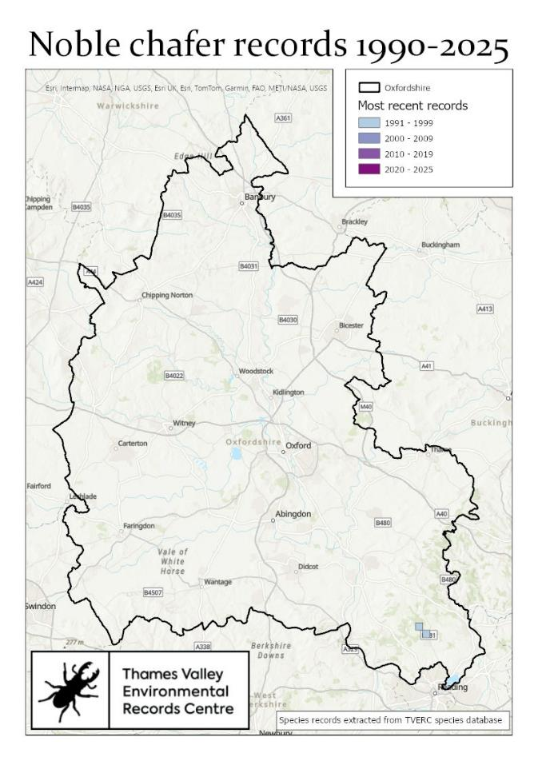 Return to list Return to list

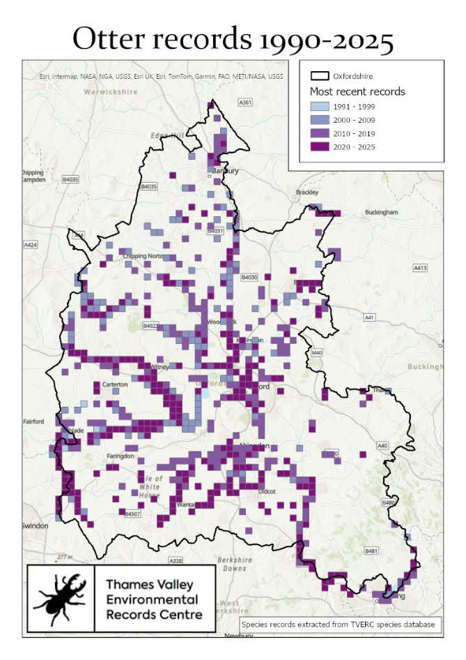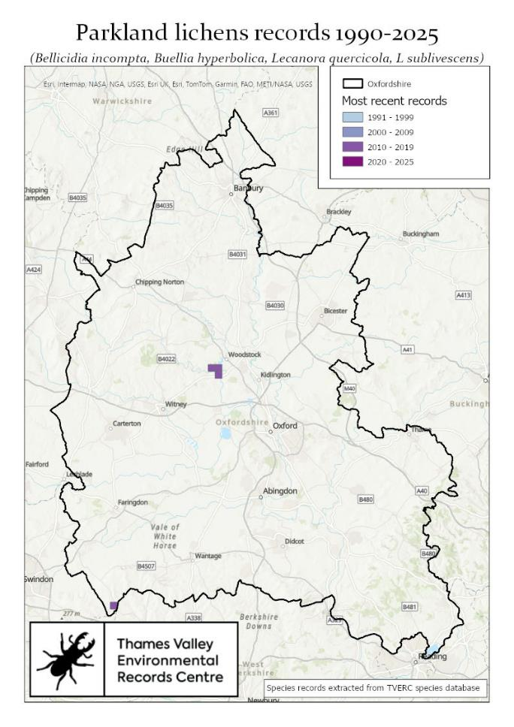
Return to list Return to list

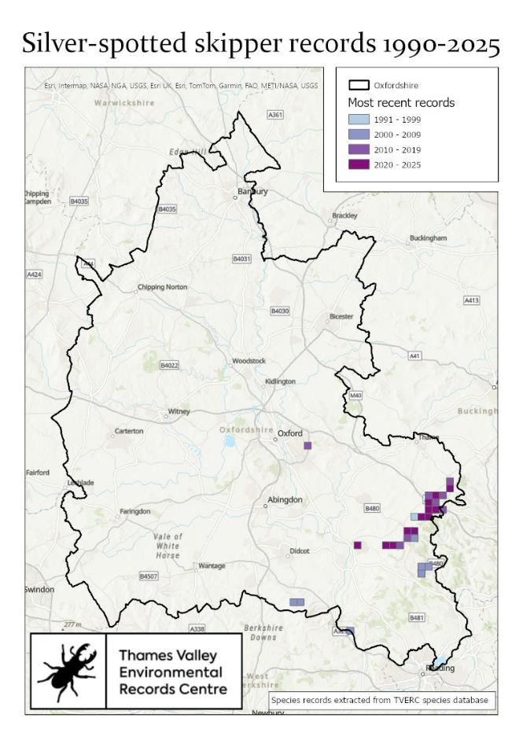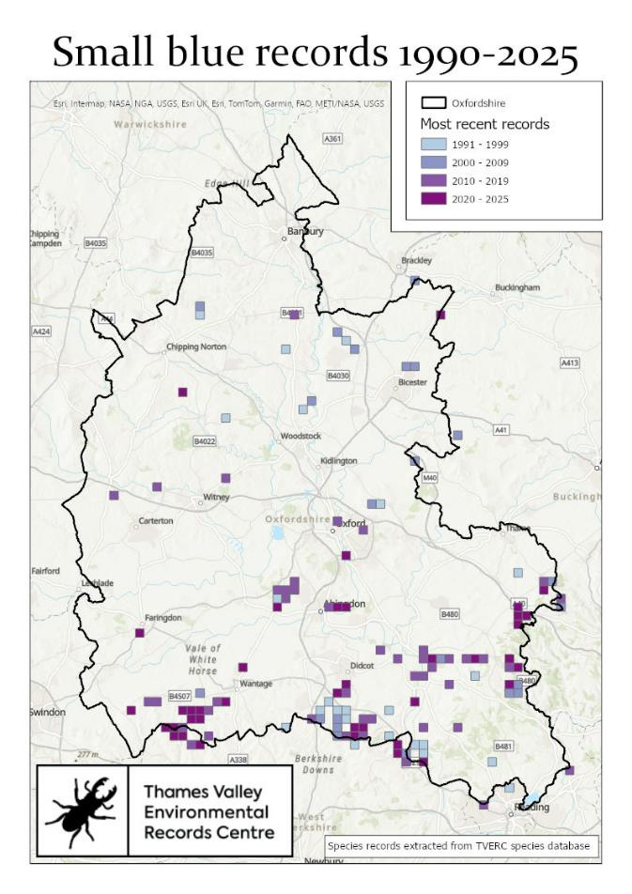
Return to list Return to list
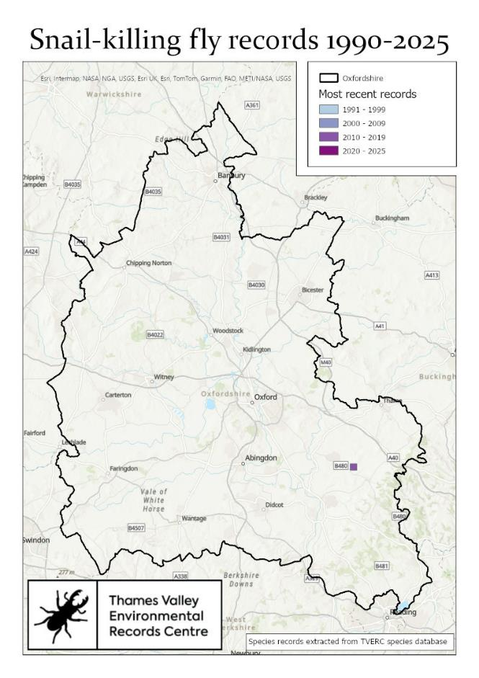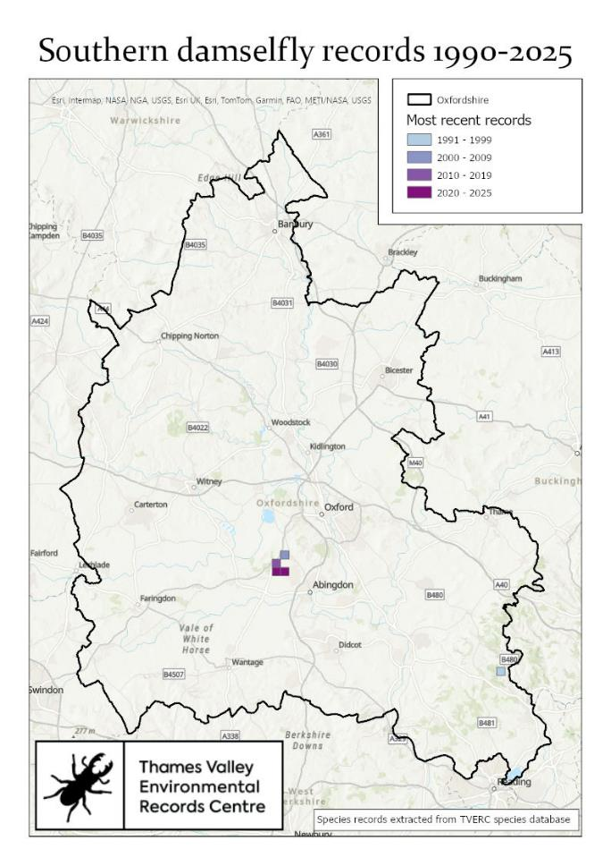
Return to list Return to list

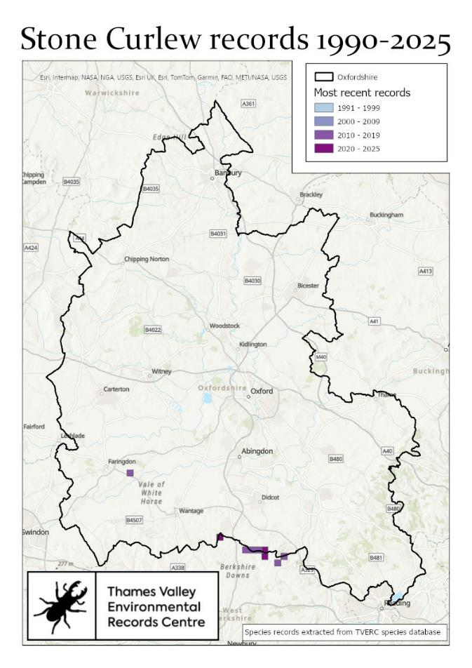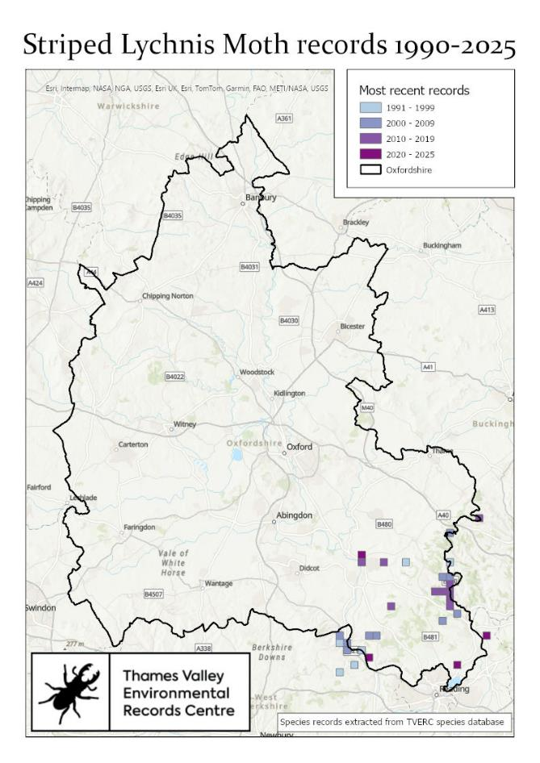
Return to list Return to list

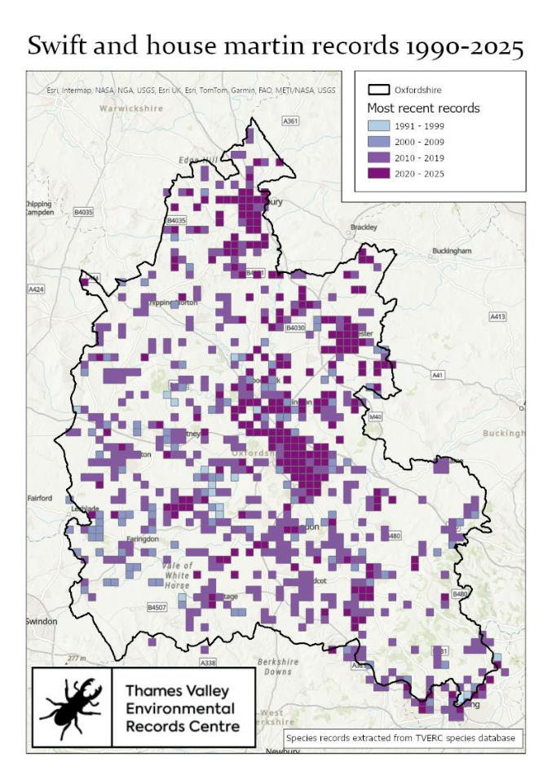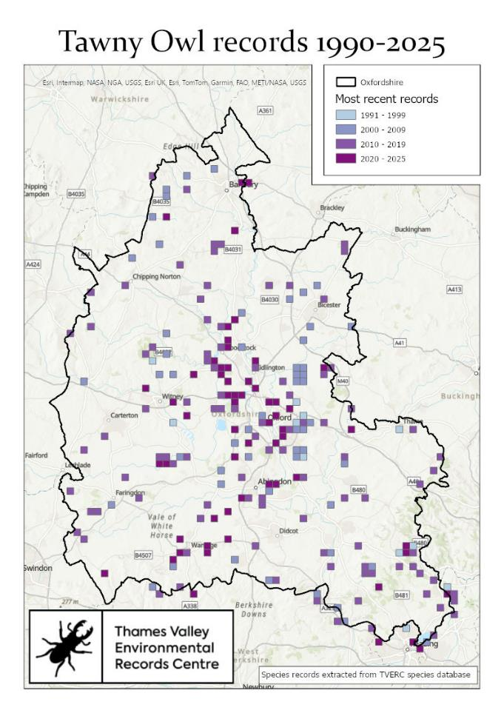
Return to list Return to list
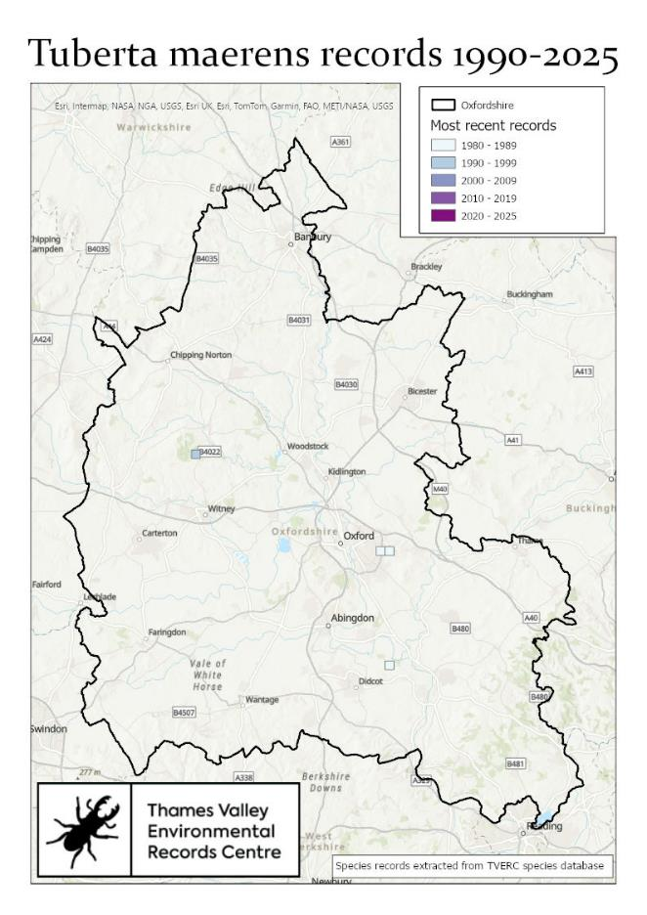
Return to list

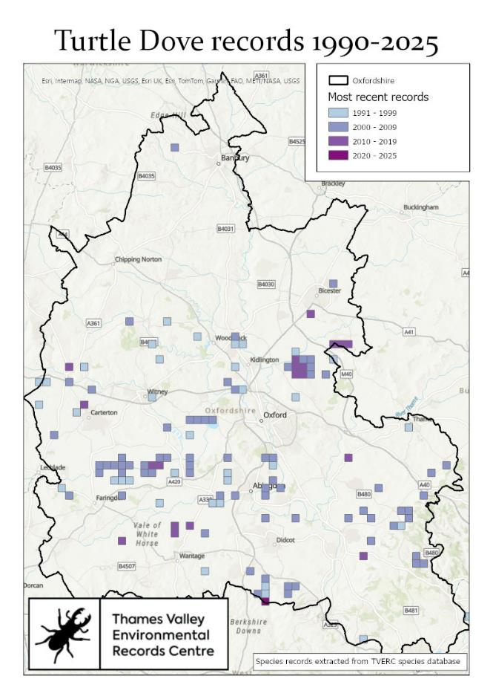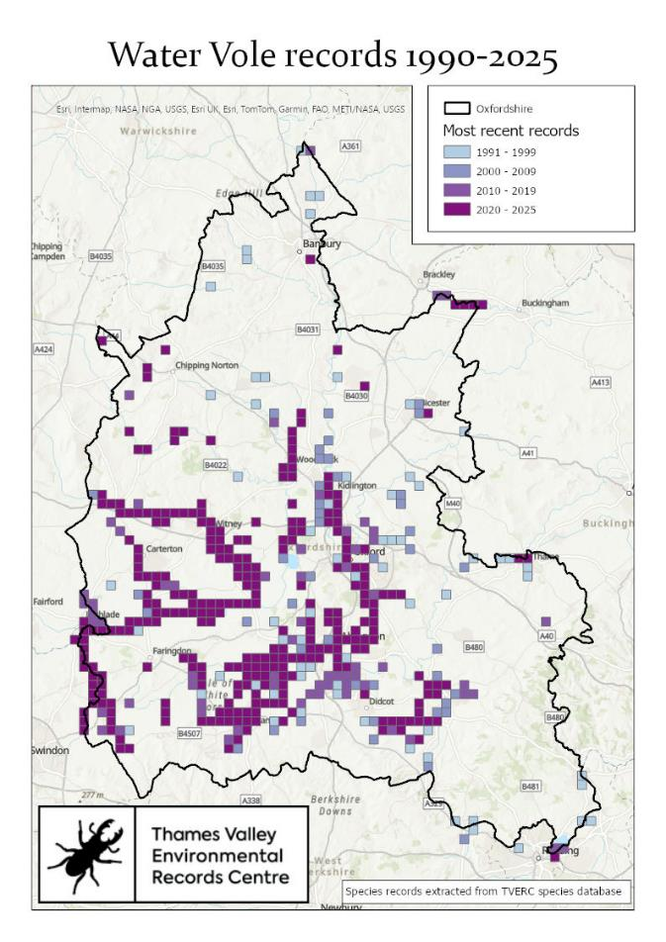
Return to list Return to list

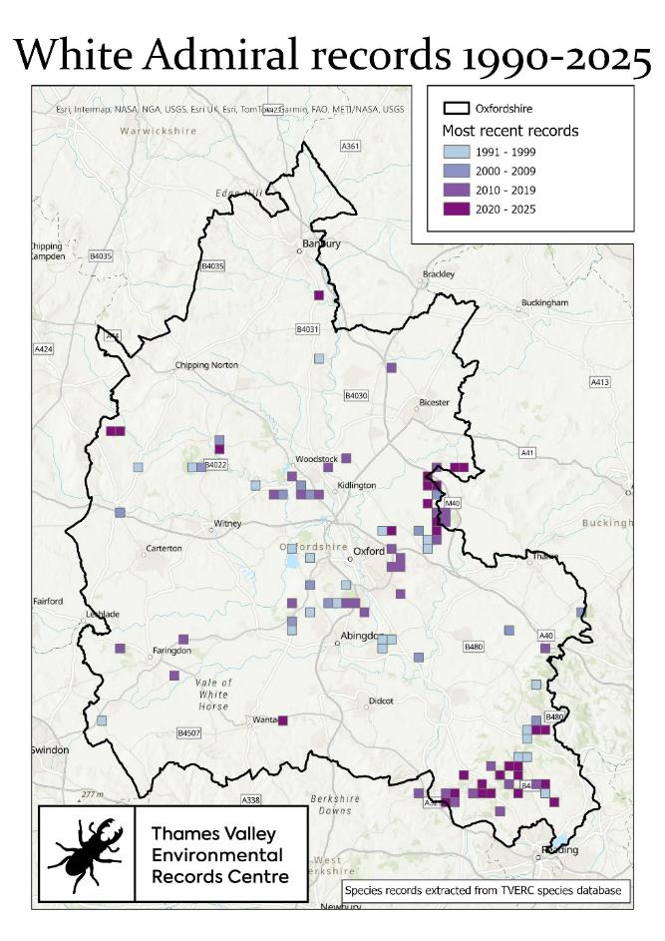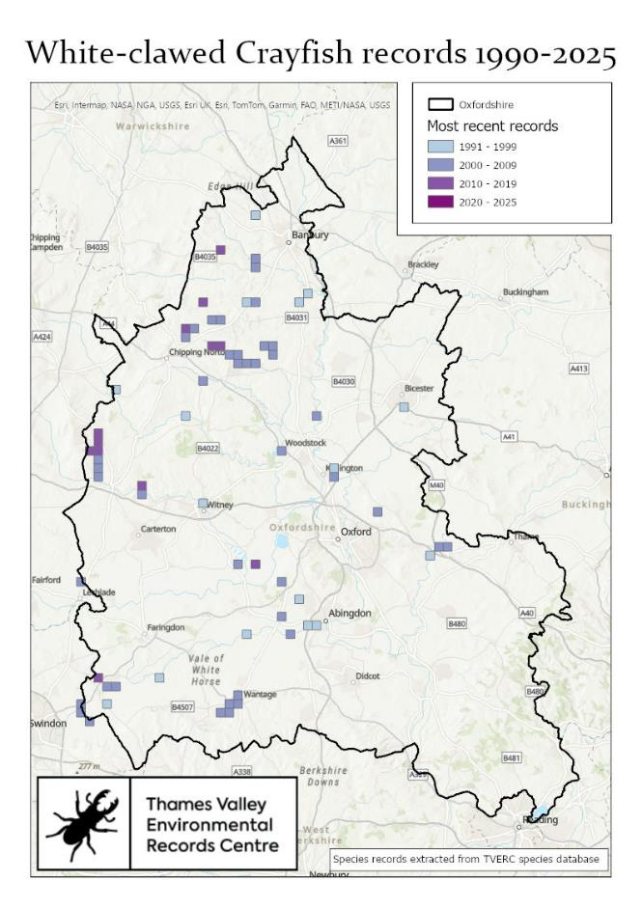
Return to list Return to list

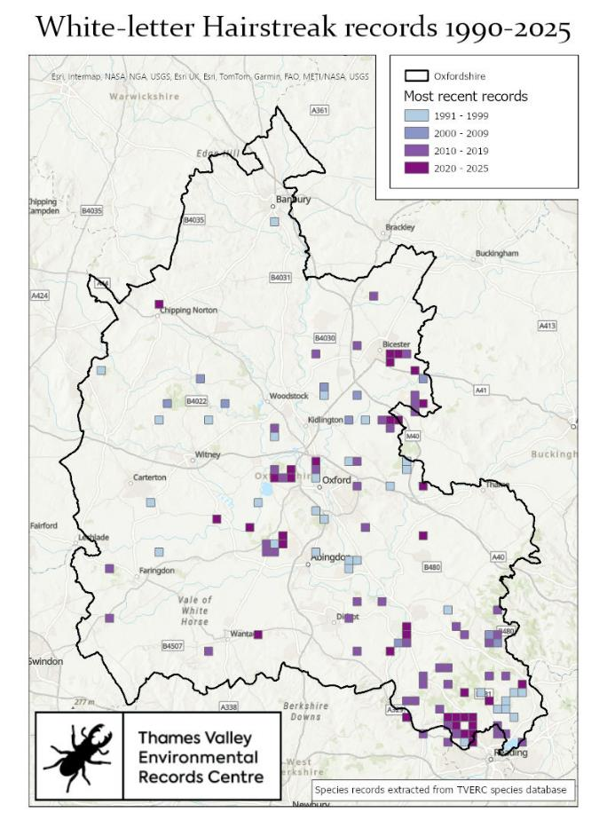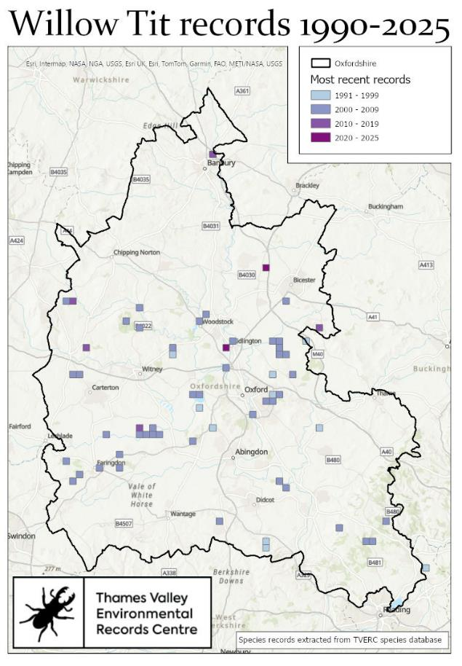

Return to list Return to list

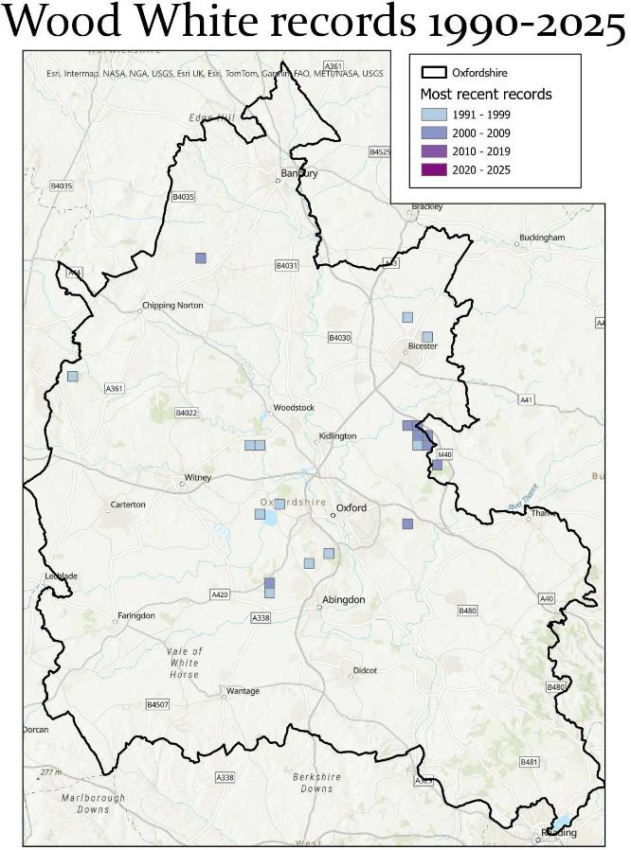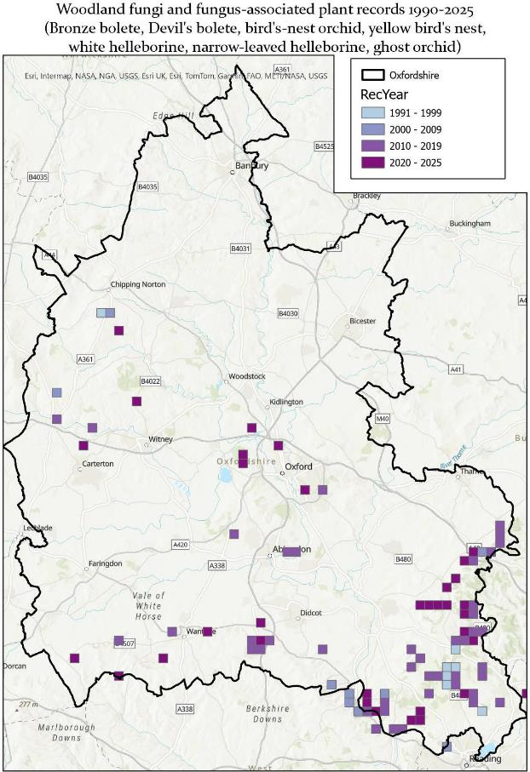
Return to list Return to list

