**Proposed Plans.**

Guildford Car Park, Burford

|  |  |  |
| --- | --- | --- |
| **Bay type** | **current** | **Proposed** |
| Standard 12-hour maximum stay | 161 | 64 (40%) |
| Standard 4-hour maximum stay | 0 | 97 (60%) |
| Blue Badge- disabled bays | 3 | 3 |
| Adult and child bays | 2 | 2 |

The front area of the car park will be 4-hour stay, and the rear will be 12 hours.

There is no time restriction to blue badge bays or adult and child bays.



Hensington Road Car Park, Woodstock

|  |  |  |
| --- | --- | --- |
| **Bay type** | **current** | **Proposed** |
| Standard 12-hour maximum stay | 101 | 35 (25%) |
| Standard 4-hour maximum stay | 0 | 66 (75%) |
| Blue Badge- disabled bays | 4 | 4 |
| EV bays | 12 | 12 |

The yellow highlighted bays will be 12-hours, and all other bays will be 4 hours.

There is no time restriction to blue badge bays or EV bays.

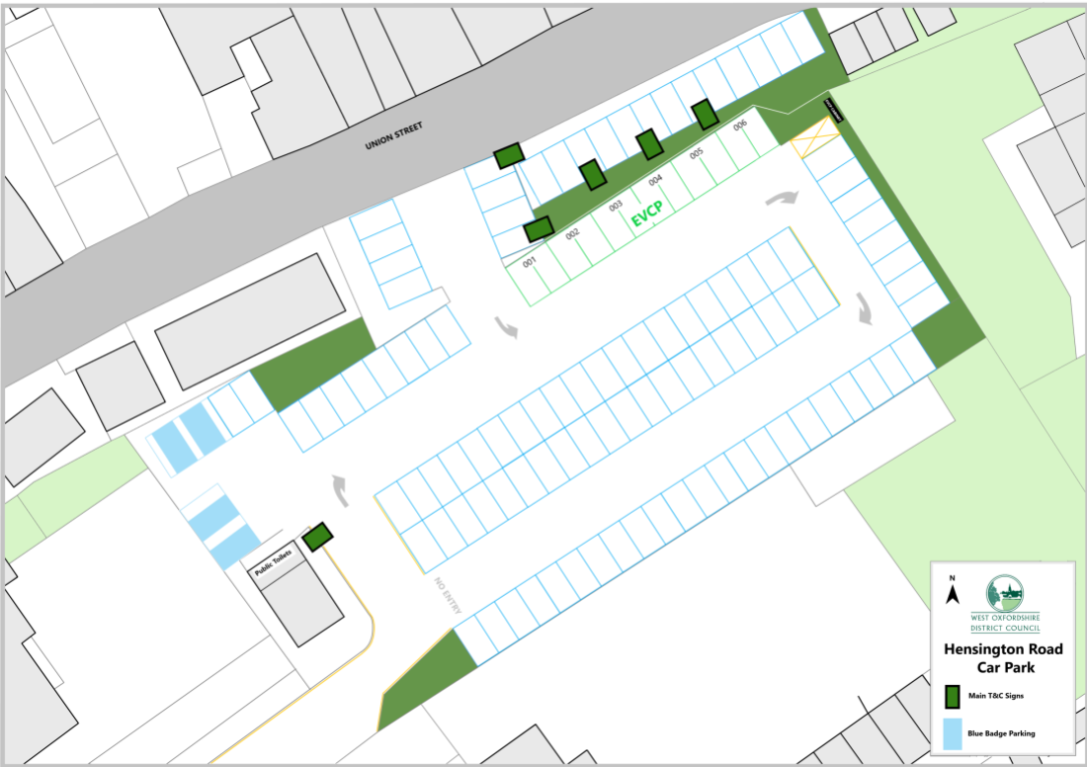



Spendlove Car Park, Charlbury

|  |  |  |
| --- | --- | --- |
| **Bay type** | **current** | **Proposed** |
| Standard 12-hour maximum stay | 26 | 0 |
| Standard 8-hour maximum stay | 0 | 10 (38%) |
| Standard 3-hour maximum stay | 0 | 24 (62%) |
| Standard 1-hour maximum stay | 7 | 0 |
| Blue Badge- disabled bays | 4 | 3 |
| Adult and child bays | 3 | 3 (3-hour max stay) |

The yellow highlighted bays will be 8-hours, and all other bays will be 3 hours.

There is no time restriction to blue badge bays.

