Pre-Application advice form

Council Offices Woodgreen WITNEY Oxfordshire OX28 1NB
Tel: 01993 861000
www.westoxon.gov.uk planning@westoxon.gov.uk
This form is for use by those who wish to seek informal advice from West Oxfordshire District Council on a planning proposal.
Please complete and return this form with your plans and any other information you believe may be useful to:
Planning and Strategic Housing, Council Offices Woodgreen WITNEY Oxfordshire OX28 1NB
Enquirer Name and Address
Name: | Address including postcode:
Tel No. | Email: | Are you the owner, intended owner or Agent?

Site Address for proposal (if different from above)
Address including postcode:
Location description (if required)

Description of the proposed work
Please provide a brief description of your proposal (attach additional sheet if required)
If your enquiry relates to an earlier refusal of Planning Permission? – what was the Application No.? |  |  |  | Application Number
Do you have a new proposal for the site you wish to discuss? |  |  |  | Yes |  | No
Site details
Please provide as much information as you can to assist us in answering your enquiry
What type or building is the existing dwelling-house? – Please tick one.
Detached house: | Semi-detached: | Terraced; | Flat:
Please answer the following questions as best you can: |  |  | (Please tick one)
 |  |  | Yes |  | No
Is the site within an Area of Flood Risk? Please consult the Environment Agency website: http://www.environment-agency.gov.uk
Does the proposal impact on any protected species? It is your responsibility to ensure that development will not have a detrimental to any protected species. Advice is provided by Natural
England on their website at: http://www.naturalengland.org.uk
Does the proposal affect any trees or hedges?
Is the site within the Cotswold Area of Outstanding Natural Beauty?
Is the site within a Conservation Area?
Proposed plans
This section sets out the information we require from you in order to provide advice on your proposal.
The information required will be dependent on your proposal.
Below is an example of the type of information we need from you

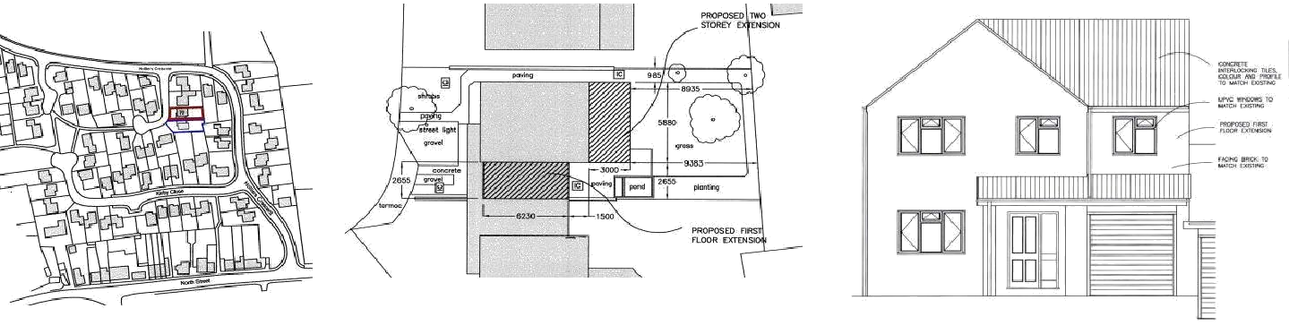

LOCATION PLAN SITE / BLOCK PLAN ELEVATION

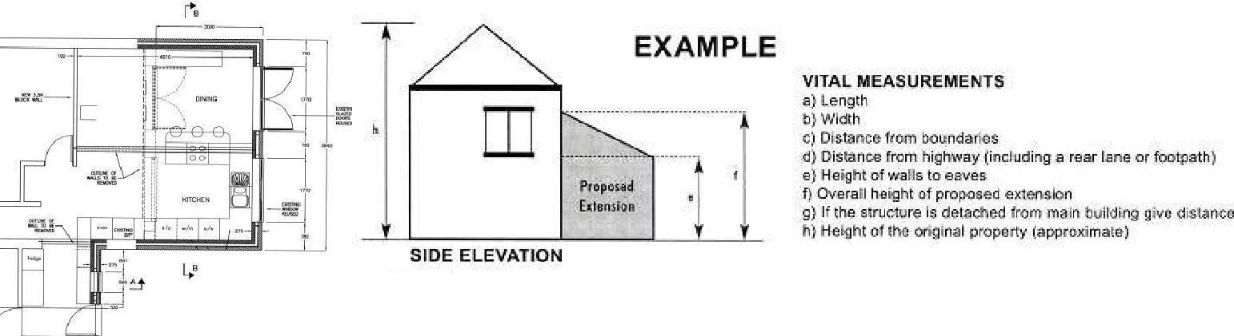

FLOORPLAN

Pre-Application information required
This list shows the minimum information requirements for a request for Pre-Application advice
All plans should show measurements or be to a recognised drawing scale.
Householder Enquiry | Basic Requirement | Additional  information require if Listed Building | Areas of Flood Risk | Area affecting Protected Species
Extensions/outbuildings | Site Plan Elevations | Internal alterations  require  Floor Plans & Materials | Environment Agency advice | Natural England advice
Garage conversion | Site Plan, Floor Plan, Elevations | Materials/Design info
Minor Alterations (windows, doors etc) or chimneys/flues | Site Plan, Elevations | Materials/Design info
Fence/Gate/Wall | Site Plan | Materials/Design info
Roof lights, Dormers or Solar Panels | Site Plan, Roof Plan Panel dimensions | Materials/Design info
Satellite Dish | Site Plan  Disc dimensions
Change of Use of Land or Buildings | Site Plan
Non-Householder Enquiry
New Building – Dwellings | Site Plan, Elevations |  | Environment  Agency advice | Natural England  advice
Change of Use of Land or Buildings / Commercial Subdivision/Conversion | Site Plan, Floor Plan,  Conversion works require Elevations | Materials/ Design info
Advertisements | Site Plan, Elevations,  Advert designs in color

Materials
(only complete for works to an existing dwelling or works ancillary to it)
 | Existing | Proposed
Walls
Roof
Floor
Doors
Windows

Fees
All pre application advice is now subject to a fee a brief overview is below and the full schedule can be found on our website here:
https://www.westoxon.gov.uk/planning-and-building/planning-permission/get-advice-on-your-application/

Materials
(only complete for works to an existing dwelling or works ancillary to it)
 | Existing | Proposed
Walls
Roof
Floor
Doors
Windows

)
Simple householder advice (does not include advice relating to development proposals for listed buildings) | £100
Complex householder advice (including advice relating to development proposals for listed buildings) | £200
Minor development for example for one dwelling (including replacement dwellings and holiday let/tourist accommodation) | £660
Has a planning condition or S.106 Legal agreement clause been complied with. | £75 + (£75 ph for complicated requests – taking more than 1 hour to be agreed in advance)

